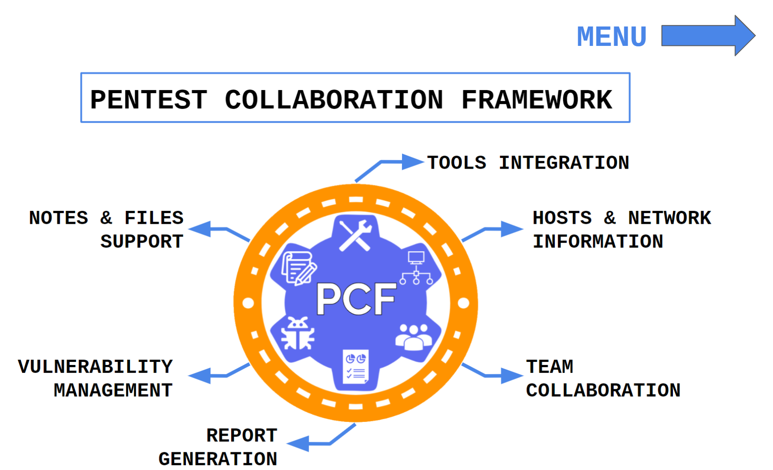

Table of Contents

Installation 4

Standalone 4

Database 4

Settings 5

Configuration File 5

Database 12

Robots.txt 12

Usage 13

Teams 13

Sequencing 13

Endpoints 14

Projects 20

Sequencing 20

Endpoints 21

Hosts 23

Sequencing 23

Endpoints 24

Networks Moderation 31

Sequencing 31

Endpoints 31

Issues moderation 36

Sequencing 36

Endpoints 36

Issue Templates 41

Issue rules 49

Reports moderation 58

Sequencing 58

Tutorial 58

Endpoints 61

Files moderation 63

Sequencing 63

Endpoints 63

Credentials moderation 65

Sequencing 65

Endpoints 66

Notes moderation 70

Sequencing 70

Endpoints 70

Chats moderation 71

Sequencing 71

Endpoints 71

Tools Usage 72

Supported tools 72

# Installation

## Standalone

**1. Install python**

apt-get install python

or install from official site: <https://www.python.org/downloads/>

**2. Install git**

apt-get install git

or install from official site: https://git-scm.com/downloads

**3. Download project:**

git clone https://gitlab.com/invuls/pentest-projects/pcf/

**4. Go to folder:**

cd pcf

**5. Install dependencies (for unix-based systems):**

pip3 install -r requirements_unix.txt

or windows:

pip.exe install -r requirements_windows.txt

**6. Run initiation script:**

python3 new_initiation.py

**7. Edit configuration:**

nano configuration/settings.ini

**8. Run:**

old version: python3 app.py

new version: python3 run.py

# Database

If you want to use PostgreSQL instead of SQLite3, change database options inside configuration/settings.ini file. Don't forget to create Postgres database and user!

# Settings

## Configuration File

/configuration/settings.txt - configuration file with major settings.

File Example

[main]

secret = frkagiz3h8a460k2wswi

debug = 0

tmp_path =./tmp_storage/

auto_delete_poc = 0

delete_projects = 0

# waitress, flask, fastwsgi

web_engine = waitress

webdav = 1

[logs]

logging = 1

log_file = ./backups/console.log

[backup]

db_backup = 1

db_backup_weeks = 1

db_backup_days = 0

db_backup_hours = 0

db_backup_minutes = 0

db_backup_seconds = 0

db_backup_amount = 3

db_backup_folder = ./backups/db/

[security]

basic_auth = 0

basic_login = pcf

basic_password = ojsflijurngrbvijsl1

# lifetime hours (1 week = 24 * 7 = 168 hours)

session_lifetime = 168

csrf_lifetime = 24

proxy_auth = 0

proxy_email_header = X-Forwarded-User

enable_form_registration = 1

enable_form_login = 1

# filesystem, memory

sessions_type = filesystem

[speedup]

external_js = 0

external_css = 0

external_img = 0

one_file_js = 1

one_file_css = 1

[database]

# sqlite3, postgres

type = sqlite3

path = ./configuration/database.sqlite3

host = 0.0.0.0

port = 5432

name = pcf

login = test_login

password = test_password

[files]

# 5 MB = 52428800 bytes

files_max_size = 52428800

poc_max_size = 52428800

template_max_size = 52428800

# storage = "filesystem" or "database"

files_storage = filesystem

poc_storage = filesystem

template_storage = filesystem

[ssl]

# only if web_engine=="flask"

ssl = 0

priv_key = ./configuration/server.key

cert = ./configuration/server.crt

[network]

host = 0.0.0.0

port = 5000

ngrok = 0

ngrok_token =

ngrok_url_file = ngrok_url.txt

[bruteforce]

top10k = ./static/files/wordlists/10-million-password-list-top-10000.txt

top1000 = ./static/files/wordlists/10-million-password-list-top-1000.txt

top100 = ./static/files/wordlists/10-million-password-list-top-100.txt

[design]

date_format_template = %%d/%%m/%%Y

report_filename_date = %%Y-%%m-%%dT%%H:%%M:%%S

[timeouts]

# timeouts in seconds

report_timeout = 10

regexp_timeout = 2

[main] parameters

[main]

secret = frkagiz3h8a460k2wswi

debug = 0

tmp_path = ./tmp_storage/

auto_delete_poc = 0

delete_projects = 0

# waitress, flask, fastwsgi

web_engine = waitress

webdav = 1

**secret** - random string, which used as a flask session. It must be changed with new_initiation.py.

**debug** - turn on/off flask debug mode.

**tmp_path** - path for tmp files. It can be changed for /tmp/ at Unix systems.

**auto_delete_poc** - turn on/off Proof-of-Concept file autoremove.

**delete_projects** - delete project from database (when click "Delete" button) or just make them invisible to users.

**web_engine** - engine to run application: "flask", "waitress" or "fastwsgi".

**webdav** - turn on/off WebDAV technology to connect to projects filesystem (files tab)

WebDAV

To get access to WebDAV, you need to open a link "http://pcf-ip:pcf-port/webdav/" using your WebDAV client, for example, OS file manager.

webdav_username == pcf_account_email

webdav_password == pcf_account_password

If you also turned on basic auth:

webdav_username == basic_auth_login + ":::" + basic_auth_password

webdav_password == pcf_account_email + ":::" + pcf_account_password

Structure:

project-name1_project-uuid/

file-name1_filename-uuid.extension

file-name2_filename-uuid.extension

project-name2_project-uuid/

file-name3_filename-uuid.extension

file-name4_filename-uuid.extension

Restrictions:

1. Move file - works!
2. Edit file - works!
3. Creating empty file - works!
4. Read file - works!
5. Rename files - works, but need a UUID of file at the end of filename (before the extension).
6. Move file from PC to webdav - works (but it in addition creates 3-5 empty files with same name due to webdav feature)
7. Delete file - works, but sometimes file can be locked (I think that fixed it, but there may be more bugs)

[logs] parameters

[logs]

logging = 1

log_file = ./backups/console.log

**logging** - turn on/off logging to file.

**log_file** - path to file with logs.

[backup] parameters

[backup]

db_backup = 1

db_backup_weeks = 1

db_backup_days = 0

db_backup_hours = 0

db_backup_minutes = 0

db_backup_seconds = 0

db_backup_amount = 3

db_backup_folder = ./backups/db/

**db_backup** - turn on/off autobackup.

**db_backup_weeks/days/hours/minutes/seconds/** - backup time range.

**db_backup_amount** - amount of database backup files.

[security] parameters

[security]

basic_auth = 0

basic_login = pcf

basic_password = 11sflijurngrbvijsl1

# lifetime hours (1 week = 24 * 7 = 168 hours)

session_lifetime = 168

csrf_lifetime = 24

proxy_auth = 0

proxy_email_header = X-Forwarded-User

enable_form_registration = 1

enable_form_login = 1

# filesystem, memory

sessions_type = filesystem

**basic_auth** - turn on/off HTTP basic authorization.

**basic_login/password** - HTTP basic authorization credentials.

**session_lifetime** - Flask session lifetime (in hours).

**csrf_lifetime** - Flask CSRF-protection token lifetime (in hours).

**proxy_auth** - Turn on/off proxy authorization.

**proxy_email_header** - If proxy authorization - this header will be users' identification.

**enable_form_registration** - Enable/disable registration form.

**enable_form_login** - Enable/disable login form.

**sessions_type** - Type of session storage. It can be "filesystem"(store all session data at filesystem) or "memory"(standard flask session cookies). Careful! Memory storage is less secure, so you need to set a complex main/secret variable.

[speedup] parameters

[speedup]

external_js = 0

external_css = 0

external_img = 0

one_file_js = 1

one_file_css = 1

**external_js** - turn on/off external JS links.

**external_css** - turn on/off external CSS/fonts links.

**external_img** - turn on/off external images links.

**one_file_js** - turn on/off joining .js files into one.

**one_file_css** - turn on/off joining .css files into one.

[database] parameters

[database]

# sqlite3, postgres

type = sqlite3

path = ./configuration/database.sqlite3

host = 0.0.0.0

port = 5432

name = pcf

login = test_login

password = test_password

**type** - database type. Now it supports only sqlite3 & postgres.

**path** - (sqlite3) path of database file.

**host** - (postgres) host of database.

**port** - (postgres) port of database.

**name** - (postgres) database name.

**login** - (postgres) database account login.

**password** - (postgres) database account password.

[files] parameters

[files]

# 5 MB = 52428800 bytes

files_max_size = 52428800

poc_max_size = 52428800

template_max_size = 52428800

# storage = "filesystem" or "database"

files_storage = filesystem

poc_storage = filesystem

template_storage = filesystem

**files_max_size** - max filesize in bytes for project files.

**poc_max_size** - max filesize in bytes for Proof-of-Concept files.

**template_max_size** - max report template filesize in bytes.

**files_storage** - storage of project files ("database" or "filesystem").

**poc_storage** - storage of Proof-of-Concept files ("database" or "filesystem").

**template_storage** - storage of report template files ("database" or "filesystem").

[ssl] parameters

[ssl]

# only if web_engine=="flask"

ssl = 0

priv_key = ./configuration/server.key

cert = ./configuration/server.crt

**ssl** - turn on/off HTTPS service (!!! Works only if main->web_engine is "flask" !!!).

**priv_key** - path to SSL key. Default SSL key is generated by new_initiation.py script at path ./configuration/server.crt

**cert** - path to SSL certificate. Default SSL certificate is generated by new_initiation.py script at path ./configuration/server.crt

**️WARNING! Flask runs slow anouph with SSL extention! Better use proxy software for this!**

[network] parameters

[network]

host = 0.0.0.0

port = 5000

ngrok = 0

ngrok_token =

ngrok_url_file = ngrok_url.txt

**host** - listening interface.

**port** - listening tcp-port.

**ngrok** - turn on/off ngrok startup ( <https://ngrok.com/> )

**ngrok_token** - token for ngrok integration (need to set!)

**ngrok_url_file** - if you running service as a daemon, you will be able to check file for generated ngrok url.

[bruteforce] parameters

[bruteforce]

top10k = ./static/files/wordlists/10-million-password-list-top-10000.txt

top1000 = ./static/files/wordlists/10-million-password-list-top-1000.txt

top100 = ./static/files/wordlists/10-million-password-list-top-100.txt

**top10k** - path to top-10k passwords list.

**top1000** - path to top-1000 passwords list.

**top100** - path to top-100 passwords list.

[design] parameters

[design]

date_format_template = %%d/%%m/%%Y

report_filename_date = %%Y-%%m-%%dT%%H:%%M:%%S

**date_format_template** - python datetime format for projects table.

**report_filename_date** - python datetime format for generated report names.

[timeouts] parameters

[timeouts]

# timeouts in seconds

report_timeout = 10

regexp_timeout = 2

**report_timeout** - timeout in seconds for report generation.

**regexp_timeout** - timeout in seconds for regexp processing (issue replace rules etc).

# Database

/configuration/database.sqlite3 - default path to database.

It can be changed inside Configuration file.

# Robots.txt

/configuration/robots.txt - file which will be returned by web-server for .../robots.txt requests. You need to fill it with discovery rules which will be used by search systems such as Google or Yandex.

# Usage

## Teams

### Sequencing

| № | Action |
| --- | --- |
| 1 | Go to new team page |
| 2 | Create new team |
| 3 | Set team options |
| 4 | Add users to created team |
| 5 | Make some of them administrators |
| 6 | Go to ️Projects page! |

### Endpoints

New Team Page

| Name | Value |
| --- | --- |
| URL | /create_team |
| URL Example | - |
| Description | Create New Team |
| Capabilities | Create new team with description |
| Comments | Do not create teams with same name |

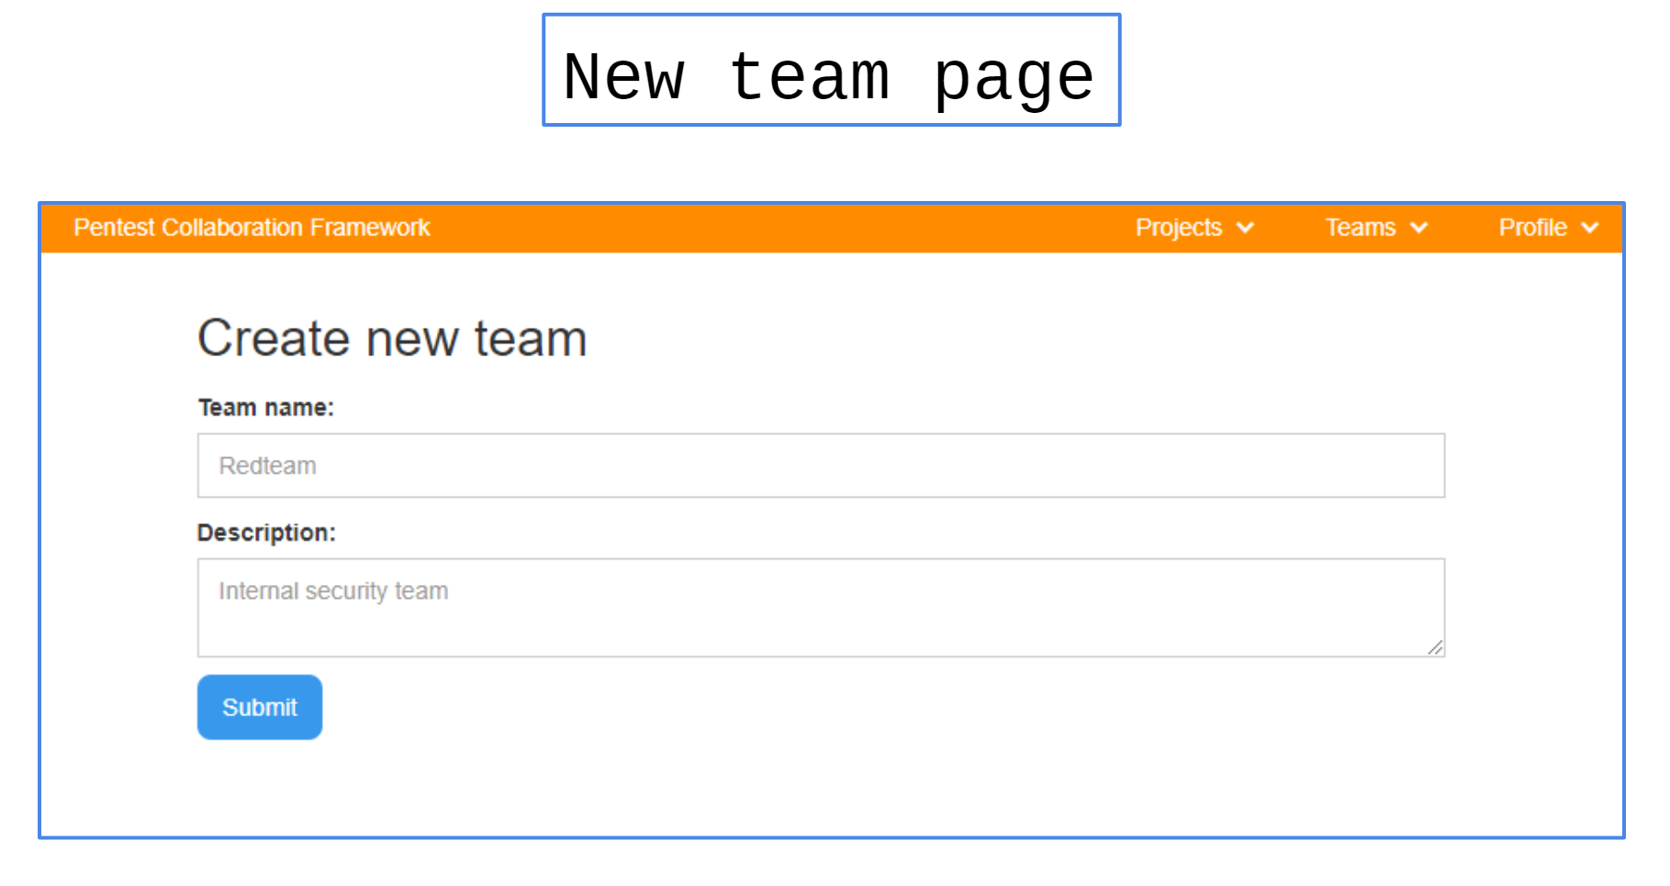

Team information

| Name | Value |
| --- | --- |
| URL | /team/{{team_UUID}} |
| URL example | /team/760a3c76-2b65-4558-9f66-876a5c772c8e/ |
| Description | Get team information |
| Capabilities | 1. Edit team information 2. Edit team users 3. Get team projects 4. Get team logs 5. Edit team configs. |
| Comments | - |

Team information: edit info

At this page you can edit team name, description and ️admin email️.

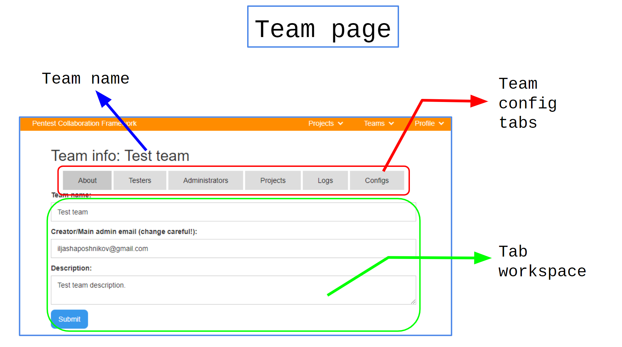Team information: testers list

At this page you can add new testers or moderate existed.

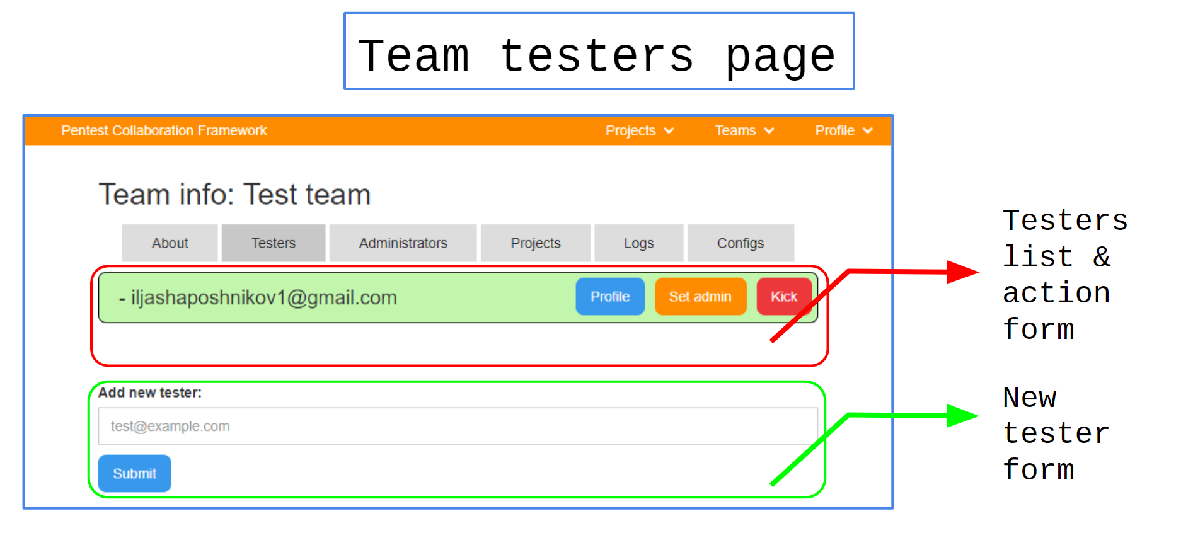

Team information: admins list

At this page you can add new administrators or moderate existed.

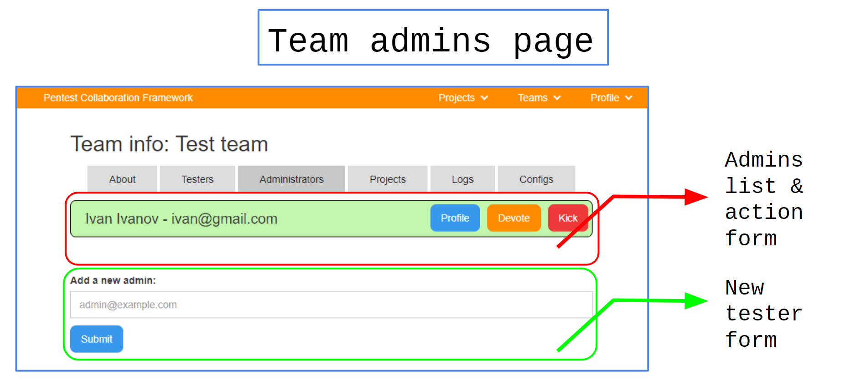

**Team Information: Projects list**

At this page you can add new projects or moderate existed.

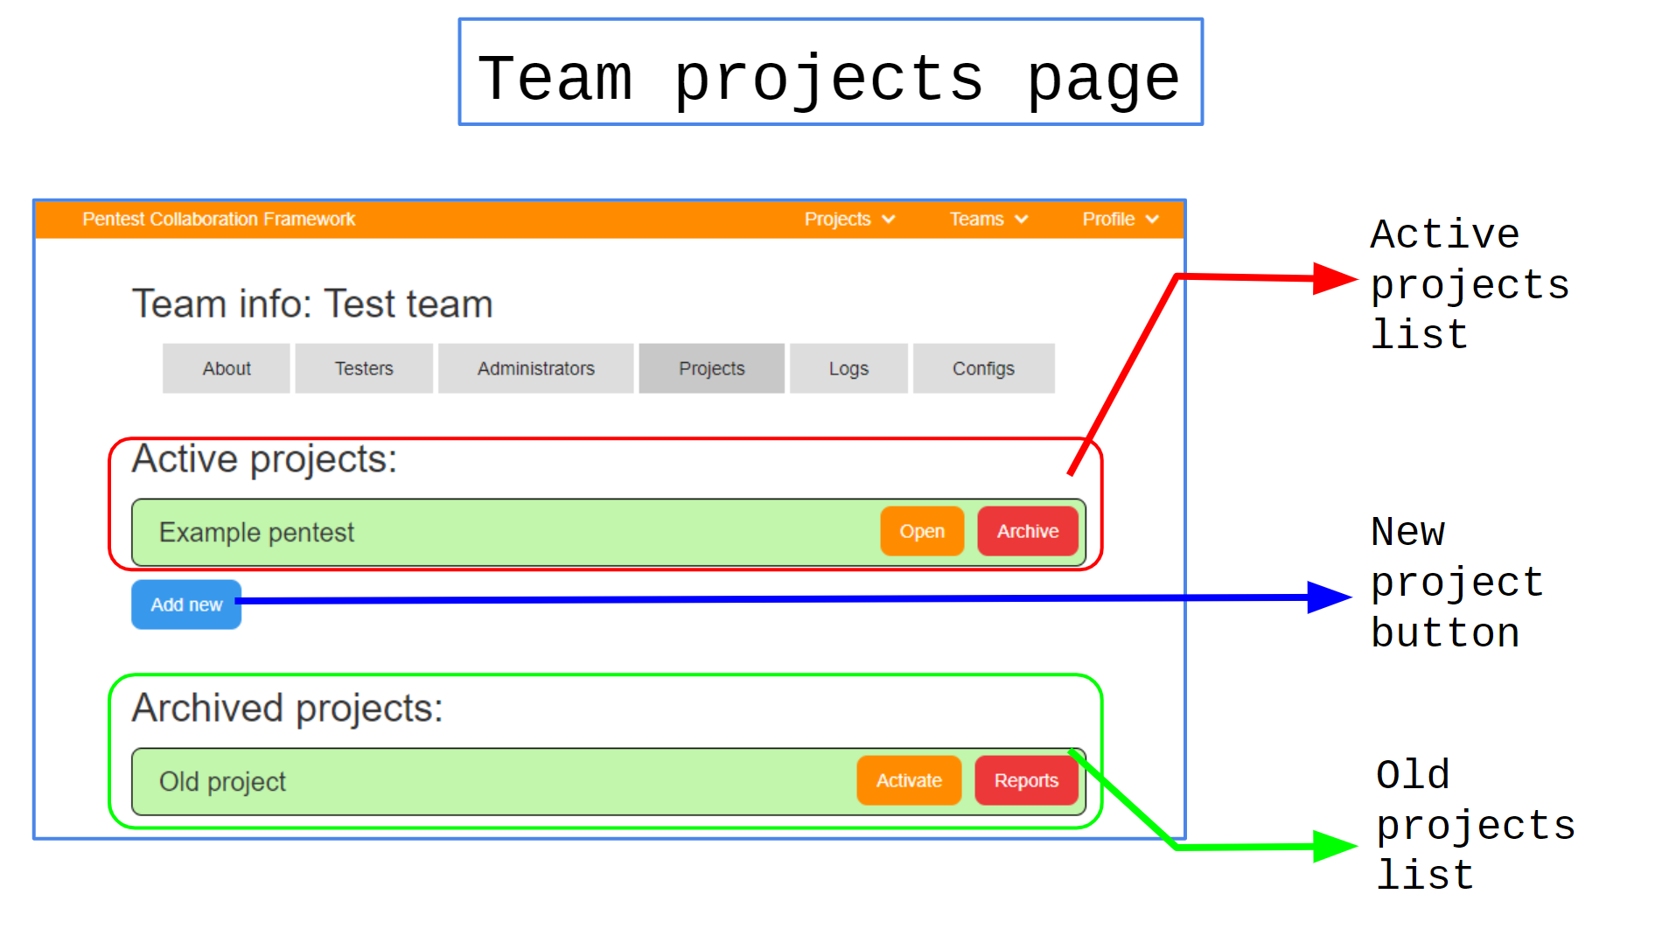

**Team Information: log file**

At this page you can get log of current team actions. There you can find any action of team or project teams even if initiator is not in team.

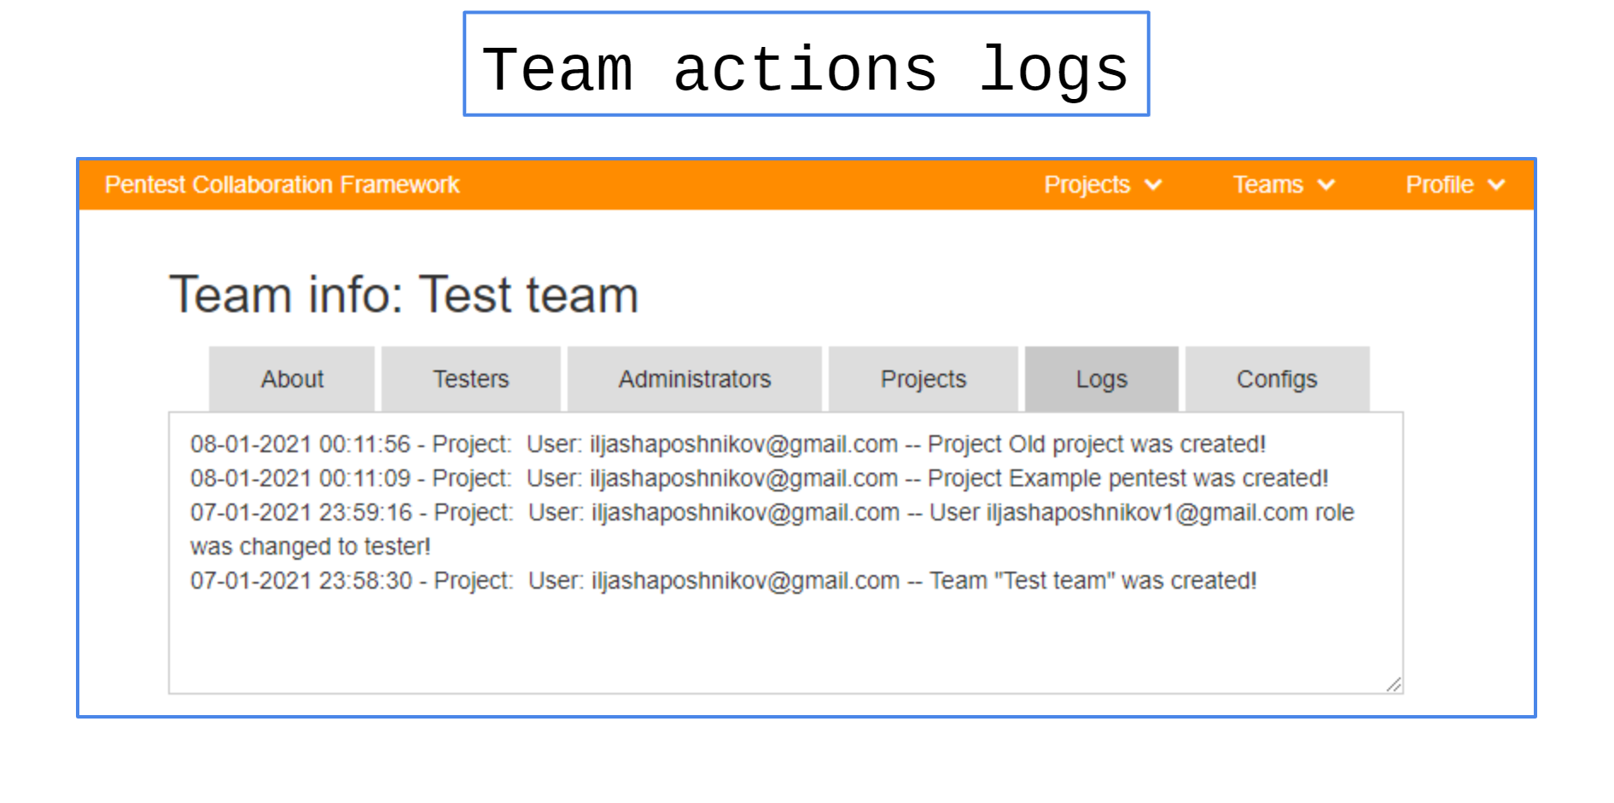

**Team Information: Variables & Templates**

At this page you can moderate team variables (usually API-tokens) and team report templates.

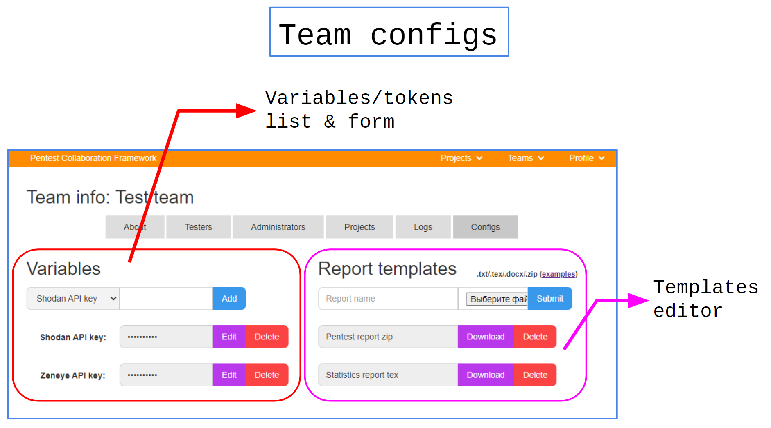

## Projects

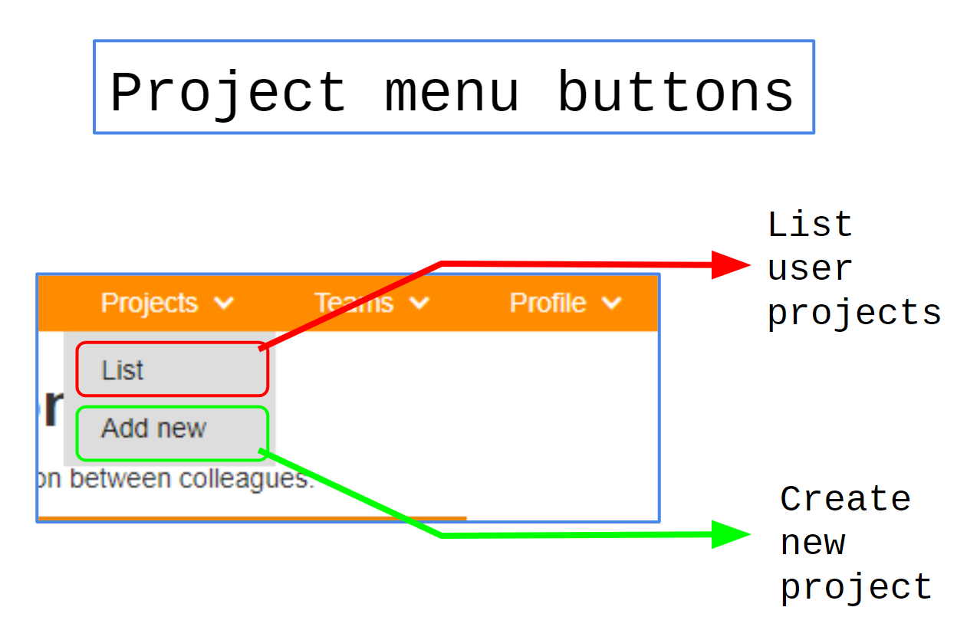

### Sequencing

You need just open new project page, set project settings and press "Create" button :)

There are two types of project:

* Active - you can change them.
* Archived - you can only read them.

**Project can't be removed due to security reasons, so be careful**

### Endpoints

Project creation

| Name | Value |
| --- | --- |
| URL | /new_project |
| URL Example | - |
| Description | Create new project |
| Capabilities | Create new project with name, scope, classification, level, and team lead |
| Comments | - |

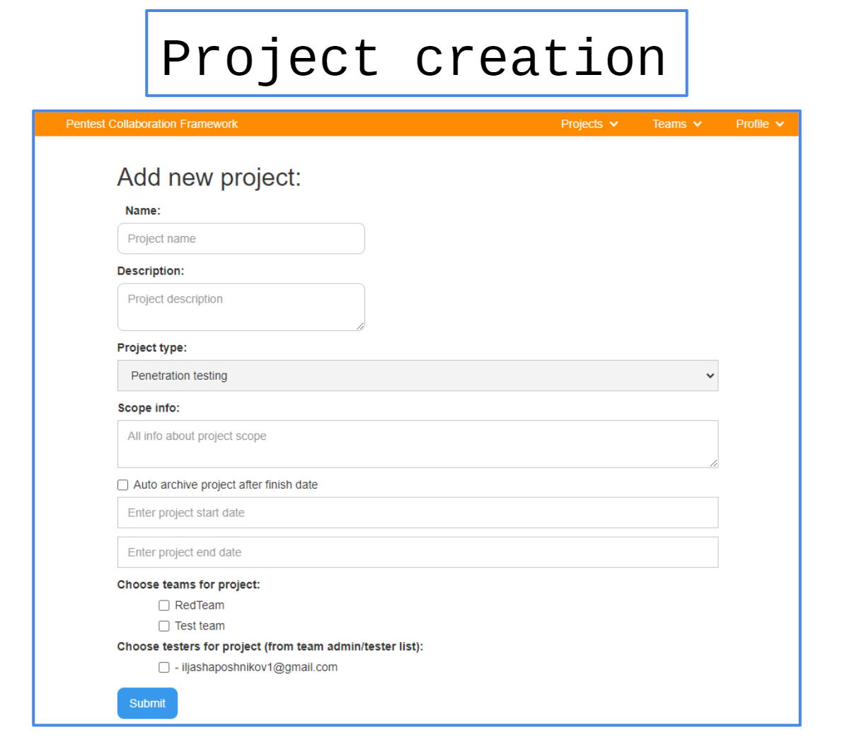  
Project stats

| Name | Value |
| --- | --- |
| URL | /project/{{project_uuid}} |
| URL example | /project/c7ff16f8-2dc8-4d70-b784-0a1d210ed784/ |
| Description | Project index page |
| Capabilities | - |
| Comments | - |

Project settings

| Name | Value |
| --- | --- |
| URL | /project/{{project_uuid}}/settings |
| URL example | /project/c7ff16f8-2dc8-4d70-b784-0a1d210ed784/ |
| Description | Project settings with edit form |
| Capabilities | Project settings with start/finish date, autoarchive, scope, description, team lead, teams, testers, classification, level, rating and more. |
| Comments | - |

## Hosts

### Sequencing

| No | Action |
| --- | --- |
| 1 | Open project hosts page |
| 2 | Open new host form |
| 3 | Create new host |
| 4 | Open created host page |
| 5 | Add ports to host |
| 6 | Add hostnames |
| 7 | (optional) Add host issues, credentials |
| 8 | Change host information |

### Endpoints

Hosts list

| Name | Value |
| --- | --- |
| URL | /project/{{project_uuid}}/hosts/ |
| URL example | /project/53ade0ed-ea2d-4812-9676-8bdcf5b7412c/hosts/ |
| Description | Project hosts list |
| Capabilities | Search for hosts, filter them or go to "Create Host" or "Export hosts" forms. |
| Comments | - |

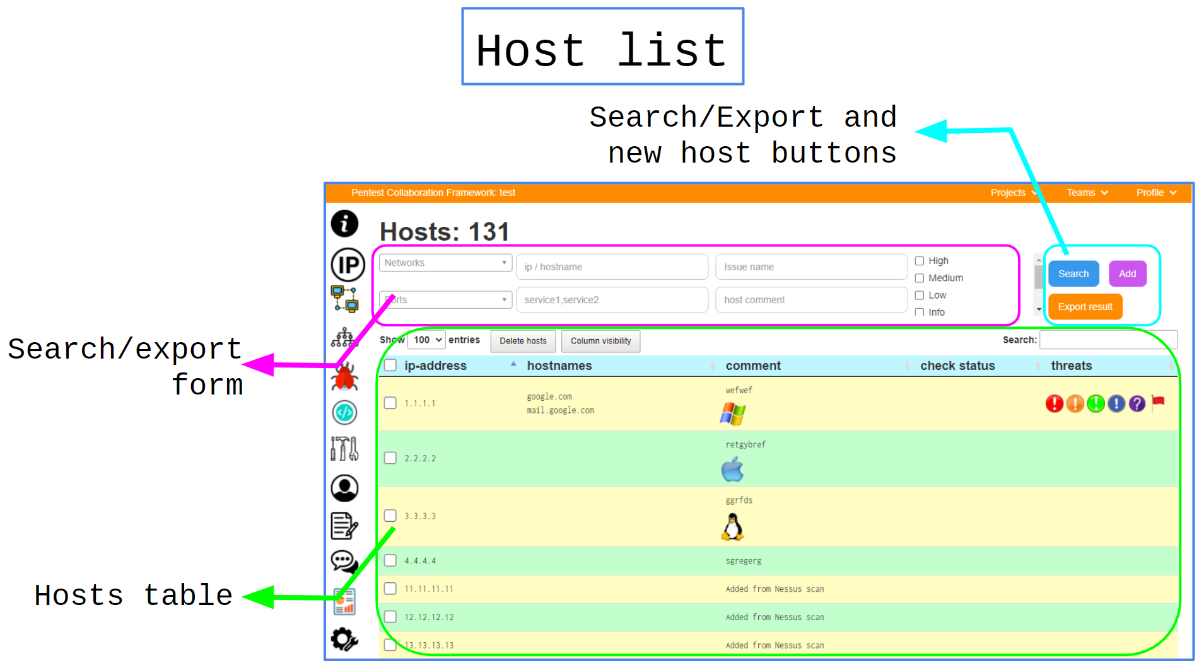  
Host creation

|  |  |
| --- | --- |
| **Name** | **Value** |
| URL | /project/{{project_uuid}}/ |
| URL example | /project/53ade0ed-ea2d-4812-9676-8bdcf5b7412c/hosts/new_host |
| Description | Project host creation page. |
| Capabilities | Create a new host with unique IP and add a comment to it. |
| Comments | It can be IPv4 or IPv6. |

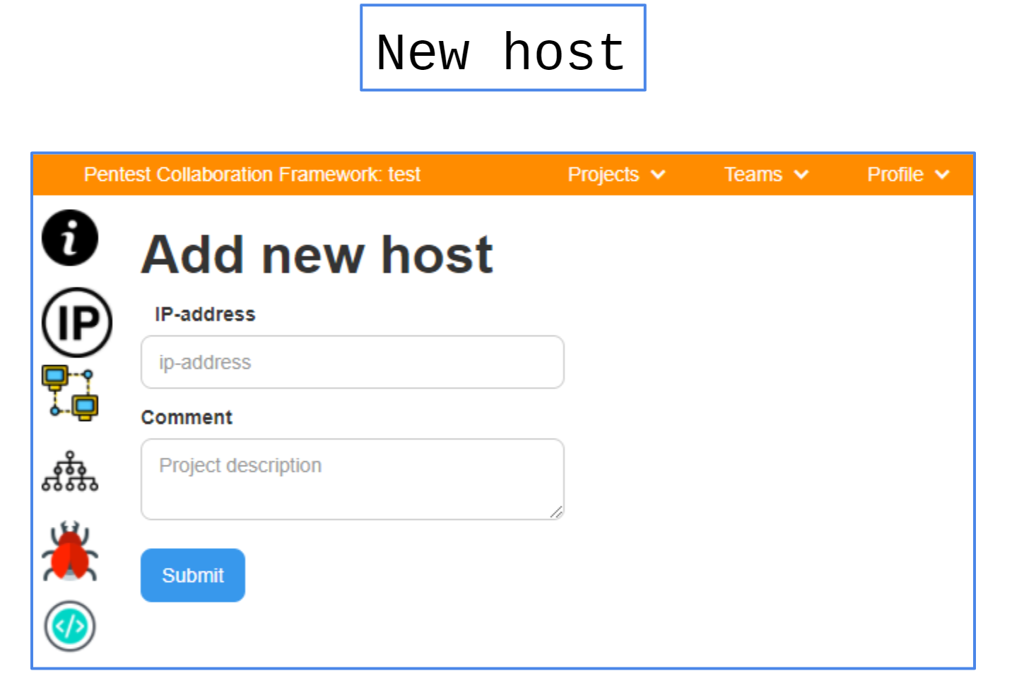  
Host information

| Name | Value |
| --- | --- |
| URL | /project/{{project_uuid}}/host/{{host_uuid}}/ |
| URL example | /project/53ade0ed-ea2d-4812-9676-8bdcf5b7412c/host/0c338176-42f0-4786-a3d8-bebd233faafc/ |
| Description | Project host information page. |
| Capabilities | 1. Edit host info 2. Modify ports 3. Modify hostnames 4. Modify issues 5. Modify credentials |
| Comments | 4. More about Issues 5. More about Credentials |

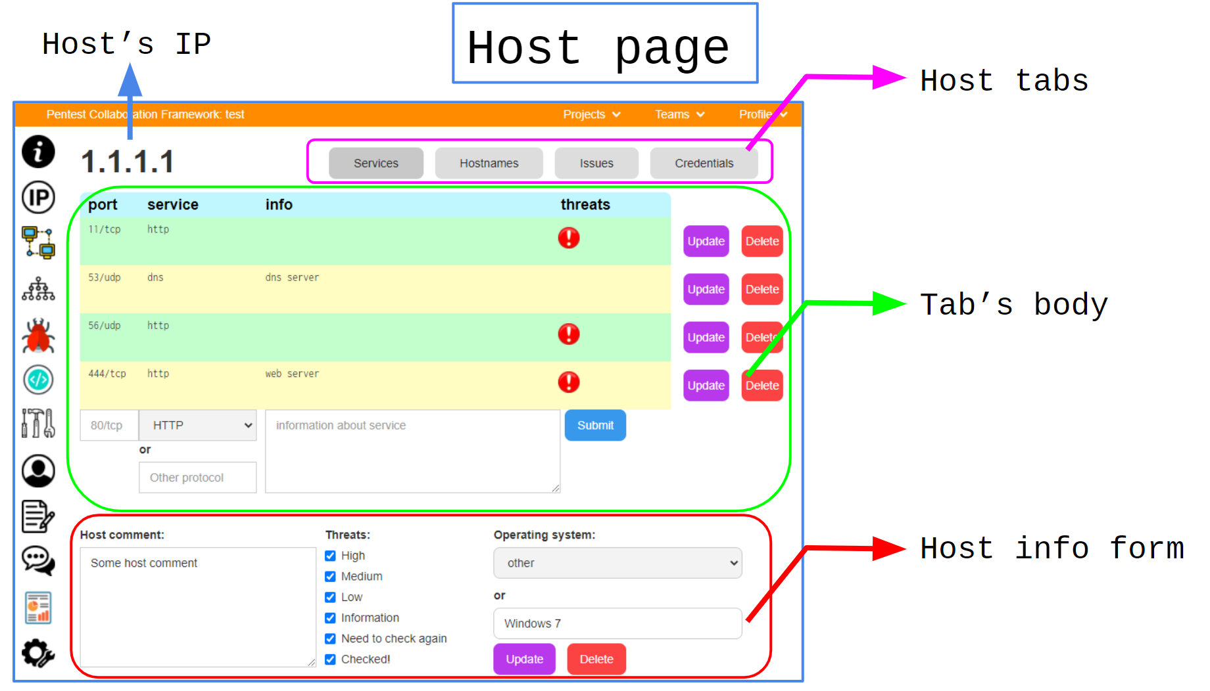  
Host information: ports

**Ports must be unique for one host!**

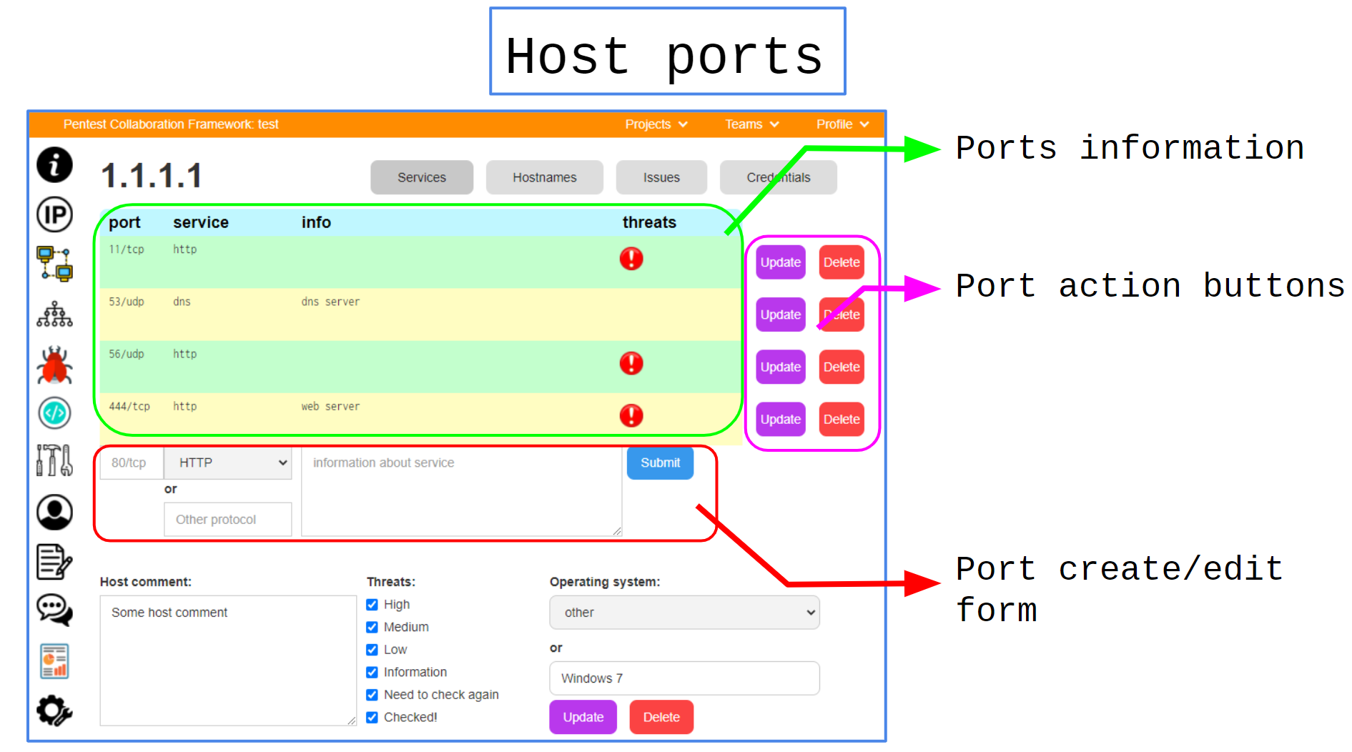**Host information: hostnames**

**Hostnames must be unique for one host!**

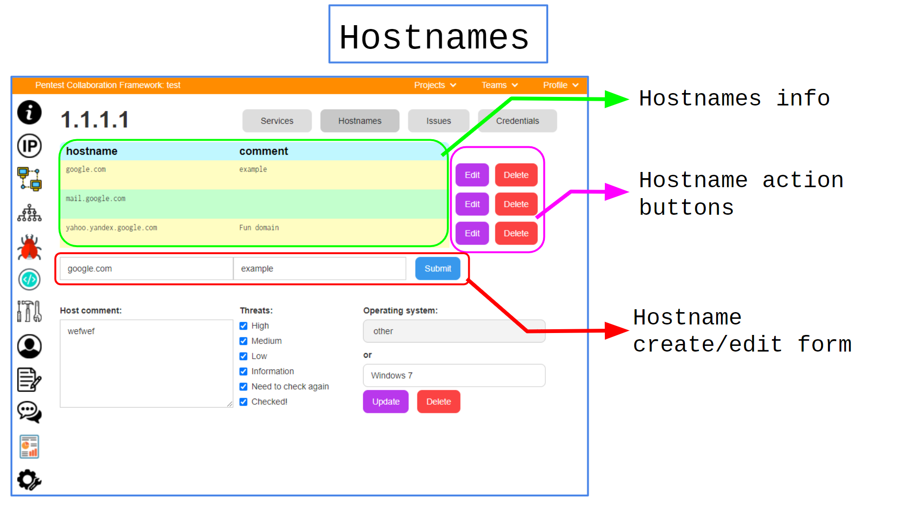 **Host information: issues**

**More info here:** **Issues**

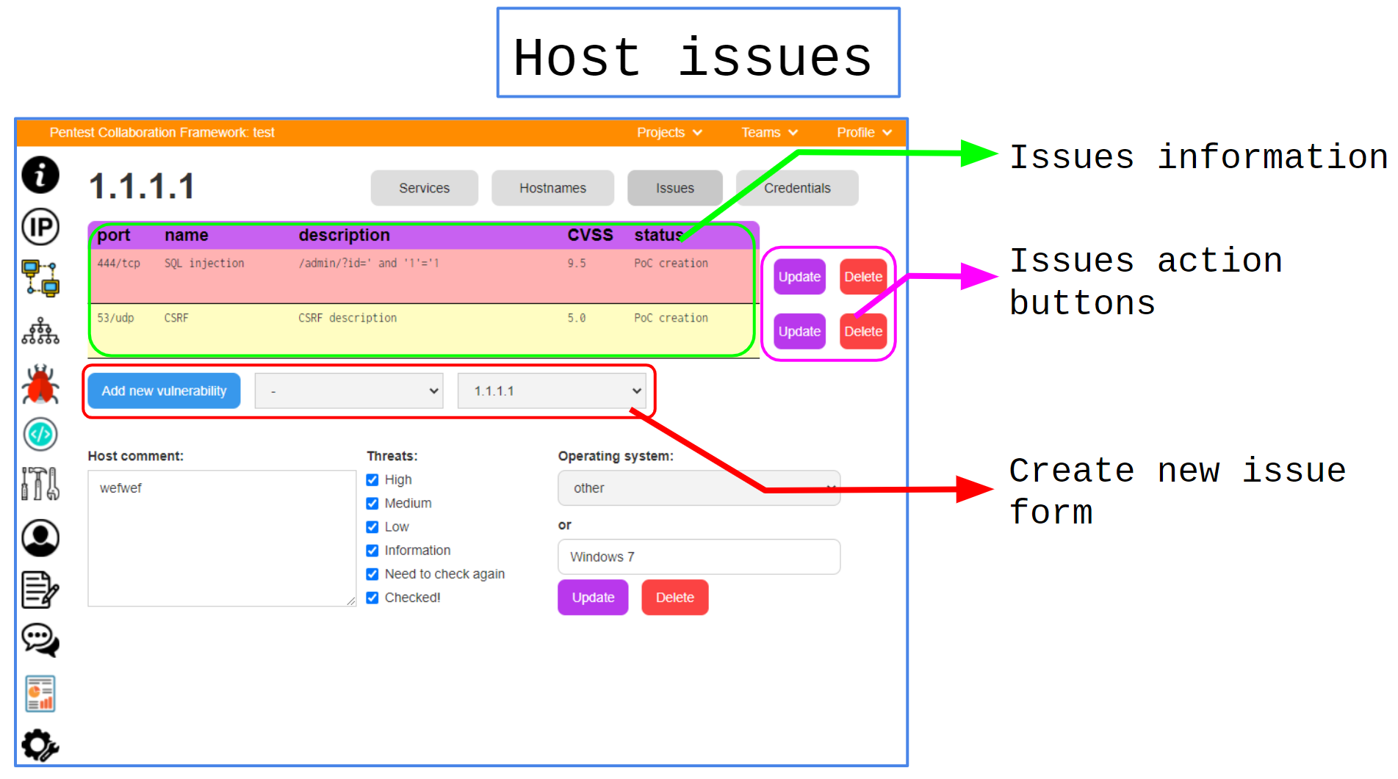 **Host information: credentials**

**More info here:** **Credentials**

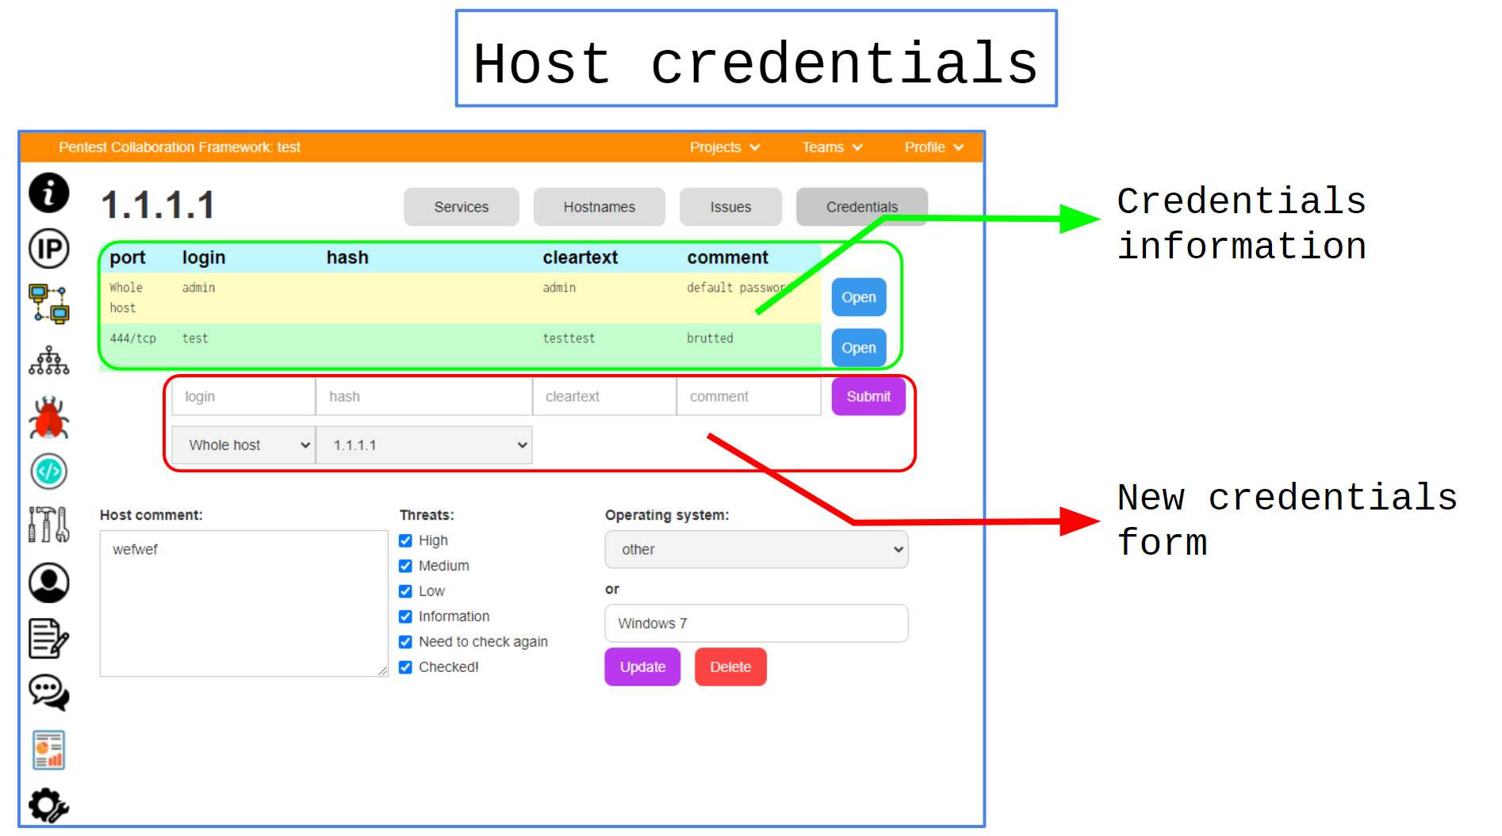 **Project services**

| Name | Value |
| --- | --- |
| URL | /project/{{project_uuid}}/services/ |
| URL example | /project/53ade0ed-ea2d-4812-9676-8bdcf5b7412c/services/ |
| Description | Project services list |
| Capabilities | Statistics with project services. |
| Comments | This page just combines information from hosts pages. |

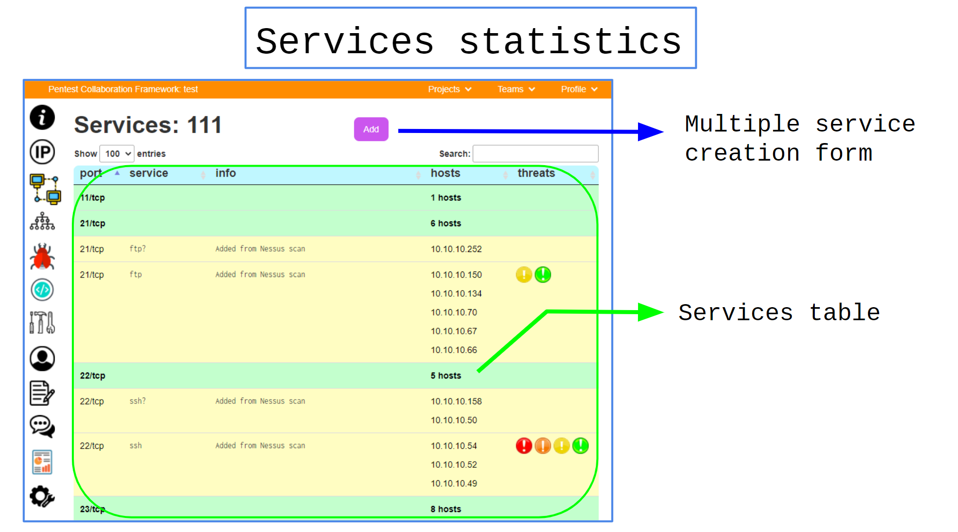 **Multiple service creation**

| Name | Value |
| --- | --- |
| URL | /project/{{project_uuid}}/services/new_service |
| URL example | /project/53ade0ed-ea2d-4812-9676-8bdcf5b7412c/services/new_service |
| Description | Project multiple services creation form. |
| Capabilities | Create service for several hosts in one form. |
| Comments | - |

## ****Networks Moderation****

### ****Sequencing****

| № | Action |
| --- | --- |
| 1 | Open new network form |
| 2 | Add new project network |
| 3 | Check it at networks list page |
| 4 | Get visualized network at networks list page |

### ****Endpoints****

**Project networks**

| Name | Value |
| --- | --- |
| URL | /project/{{project_uuid}}/networks/ |
| URL example | /project/53ade0ed-ea2d-4812-9676-8bdcf5b7412c/networks/ |
| Description | Project networks list and visualization. |
| Capabilities | 1. List of project networks 2. New network button 3. Network info/filter buttons 4. Network graph |
| Comments | Network traffic rules in development. |

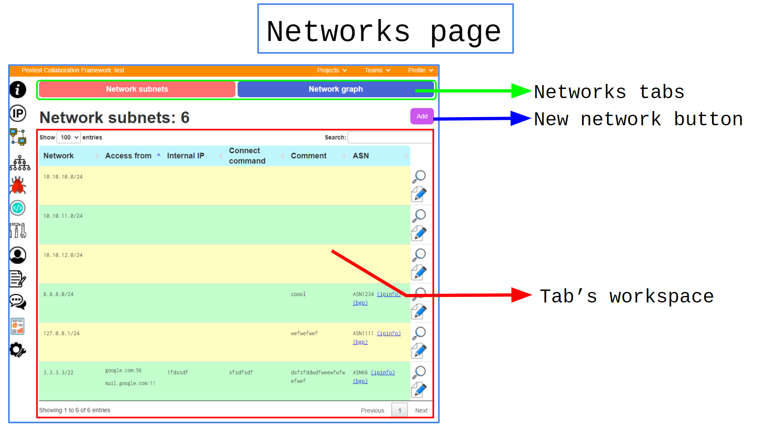 **Networks list**

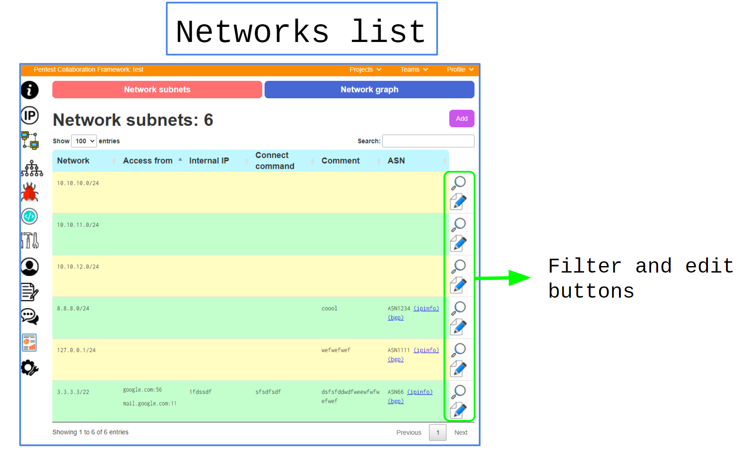 **Networks graph  
These variable are used for generating graph:**

1. Host IPs
2. Host OS
3. Networks

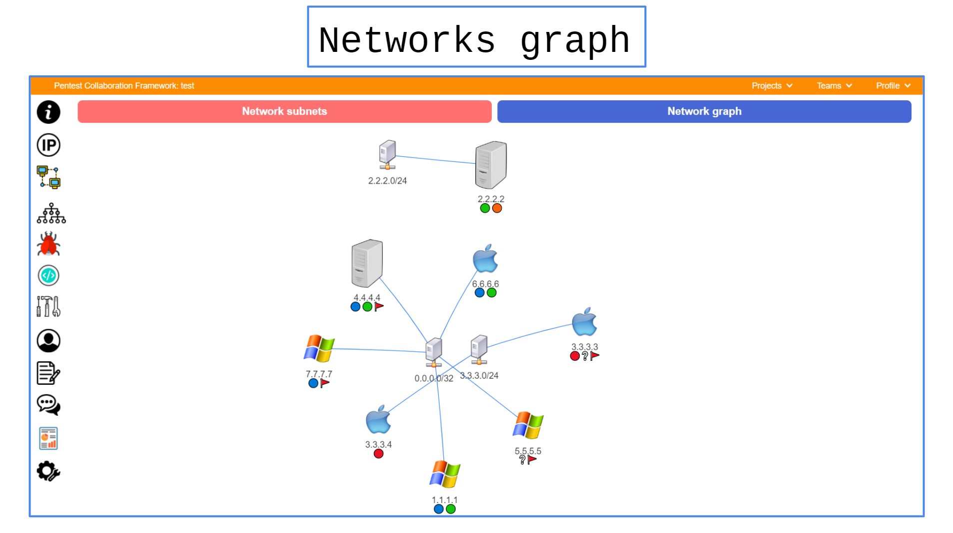 **New network**

| Name | Value |
| --- | --- |
| URL | /project/{{project_uuid}}/networks/new_network |
| URL example | /project/53ade0ed-ea2d-4812-9676-8bdcf5b7412c/networks/new_network |
| Description | Project network creation form. |
| Capabilities | Create a new network with some information. |
| Comments | - |

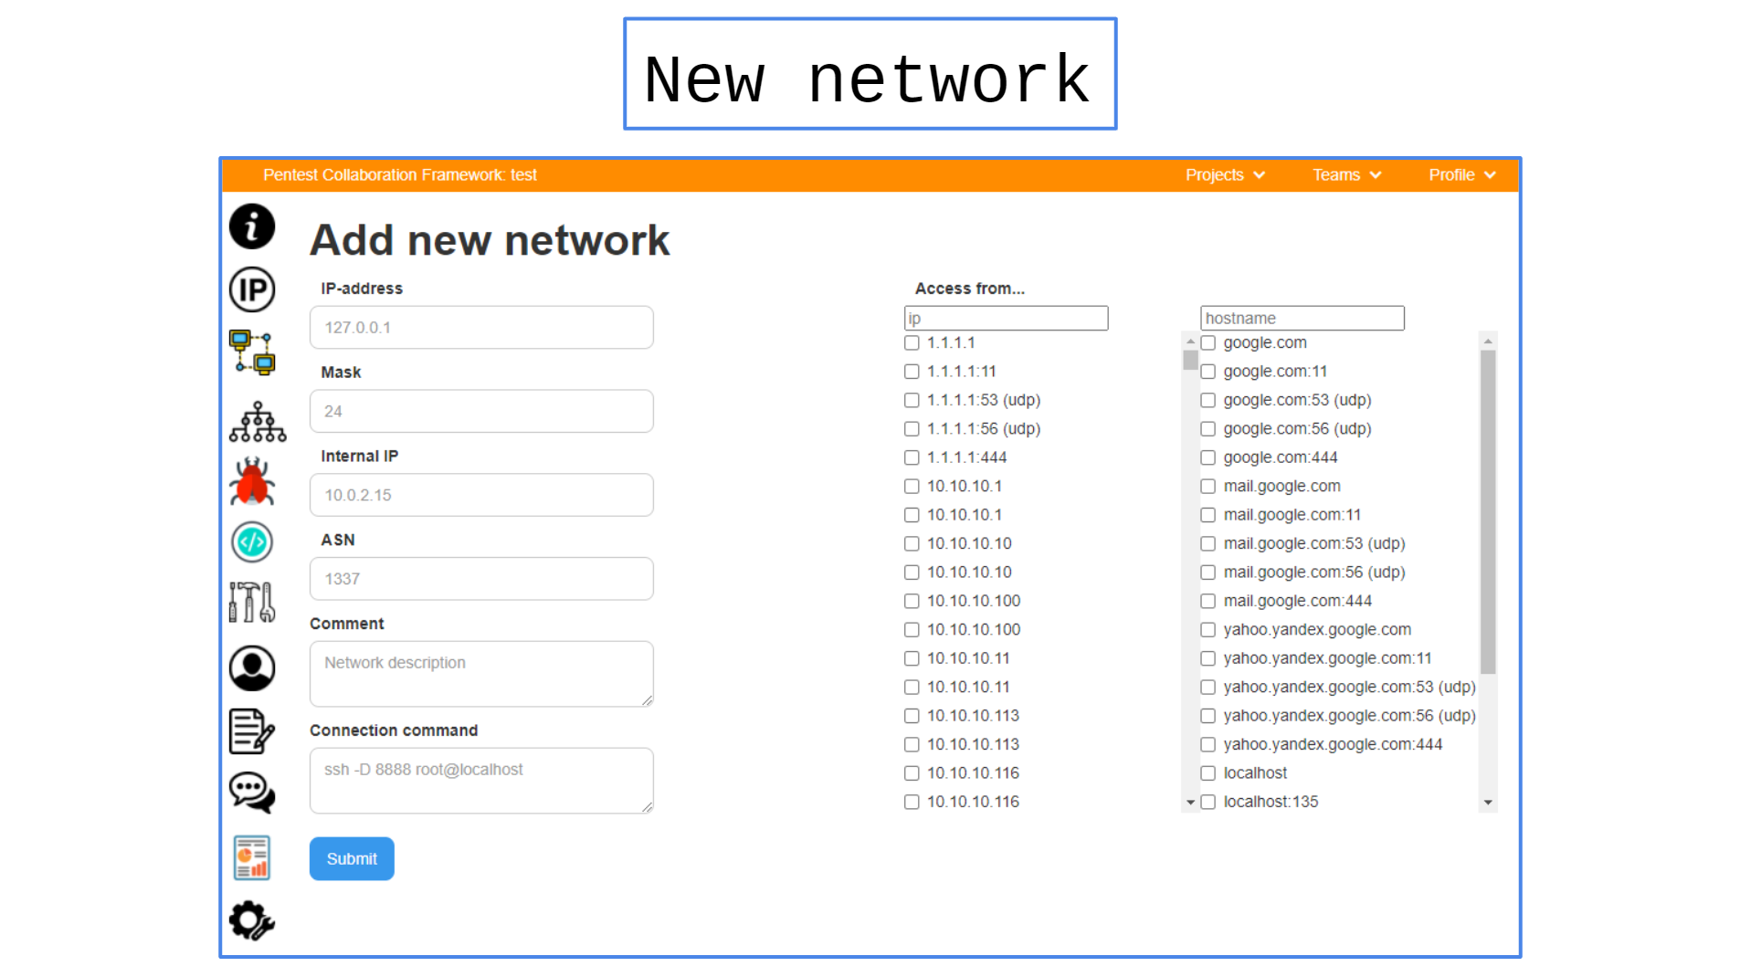 **Network page**

| Name | Value |
| --- | --- |
| URL | /project/{{project_uuid}}/networks/{{network_uuid}}/ |
| URL example | /project/53ade0ed-ea2d-4812-9676-8bdcf5b7412c/networks/a8bd03fe-cd9b-4f22-bb08-e8ad6a161ae2/ |
| Description | Network information and edit form. |
| Capabilities | View, modify and delete network. |
| Comments | - |

## ****Issues moderation****

### ****Sequencing****

| № | Action |
| --- | --- |
| 1 | Open new network form |
| 2 | Add new project network |
| 3 | Check it at networks list page |
| 4 | Get visualized network at networks list page |

### ****Endpoints****

**Issues list**

| Name | Value |
| --- | --- |
| URL | /project/{{project_uuid}}/issues/ |
| URL example | /project/53ade0ed-ea2d-4812-9676-8bdcf5b7412c/issues/ |
| Description | Project issues list. |
| Capabilities | 1. List of project issues 2. Issues search form 3. New issue button |
| Comments | Different colors - different issues criticality (CVSSv3) |

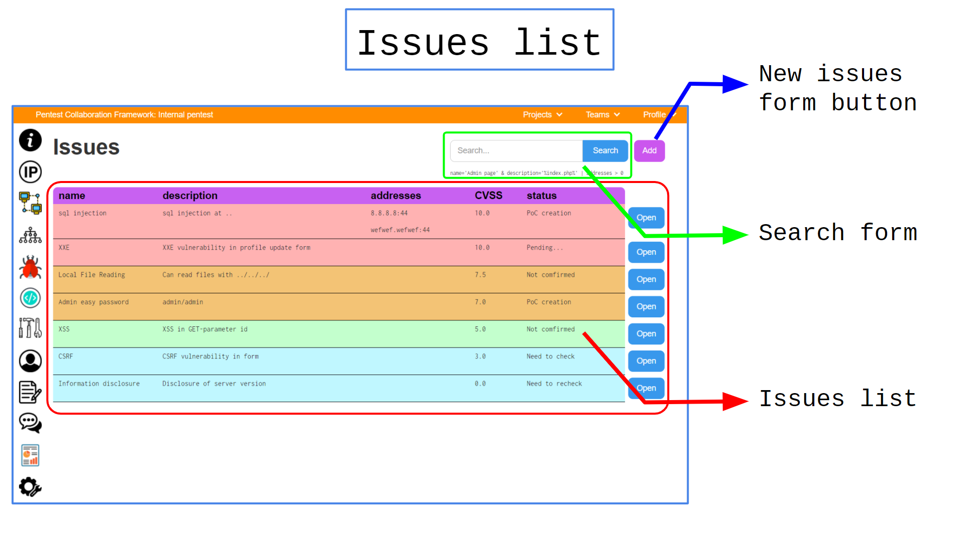 **New Issue**

| Name | Value |
| --- | --- |
| URL | /project/{{project_uuid}}/new_issue |
| URL example | /project/53ade0ed-ea2d-4812-9676-8bdcf5b7412c/new_issue |
| Description | New issue form. |
| Capabilities | Create new issue in current project. |
| Comments | Some of additional fields will be available only after issue creation. |

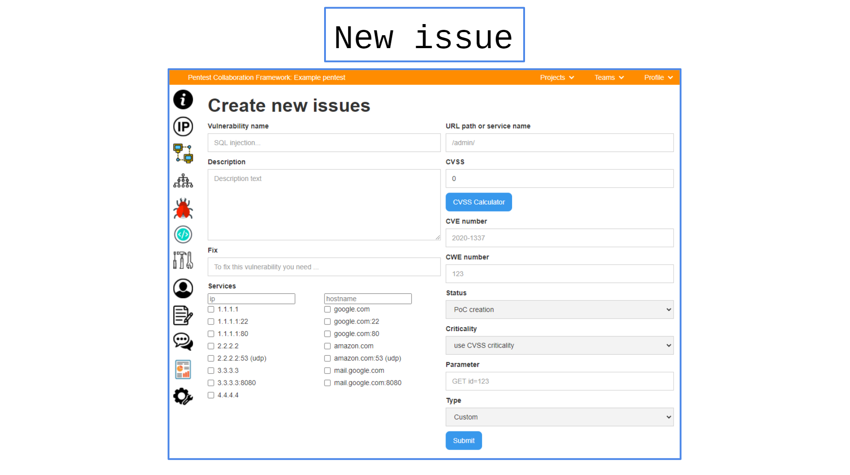 **Issue information**

| Name | Value |
| --- | --- |
| URL | /project/{{project_uuid}}/issue/{{issue_uuid}}/ |
| URL example | /project/53ade0ed-ea2d-4812-9676-8bdcf5b7412c/issue/3037349b-0111-4a62-a92d-4d10c5337daf/ |
| Description | Issue information and edit forms. |
| Capabilities | 1. View/Edit issue information 2. Delete vulnerability 3. Moderate issue's Proof-of-Concepts |
| Comments | - |

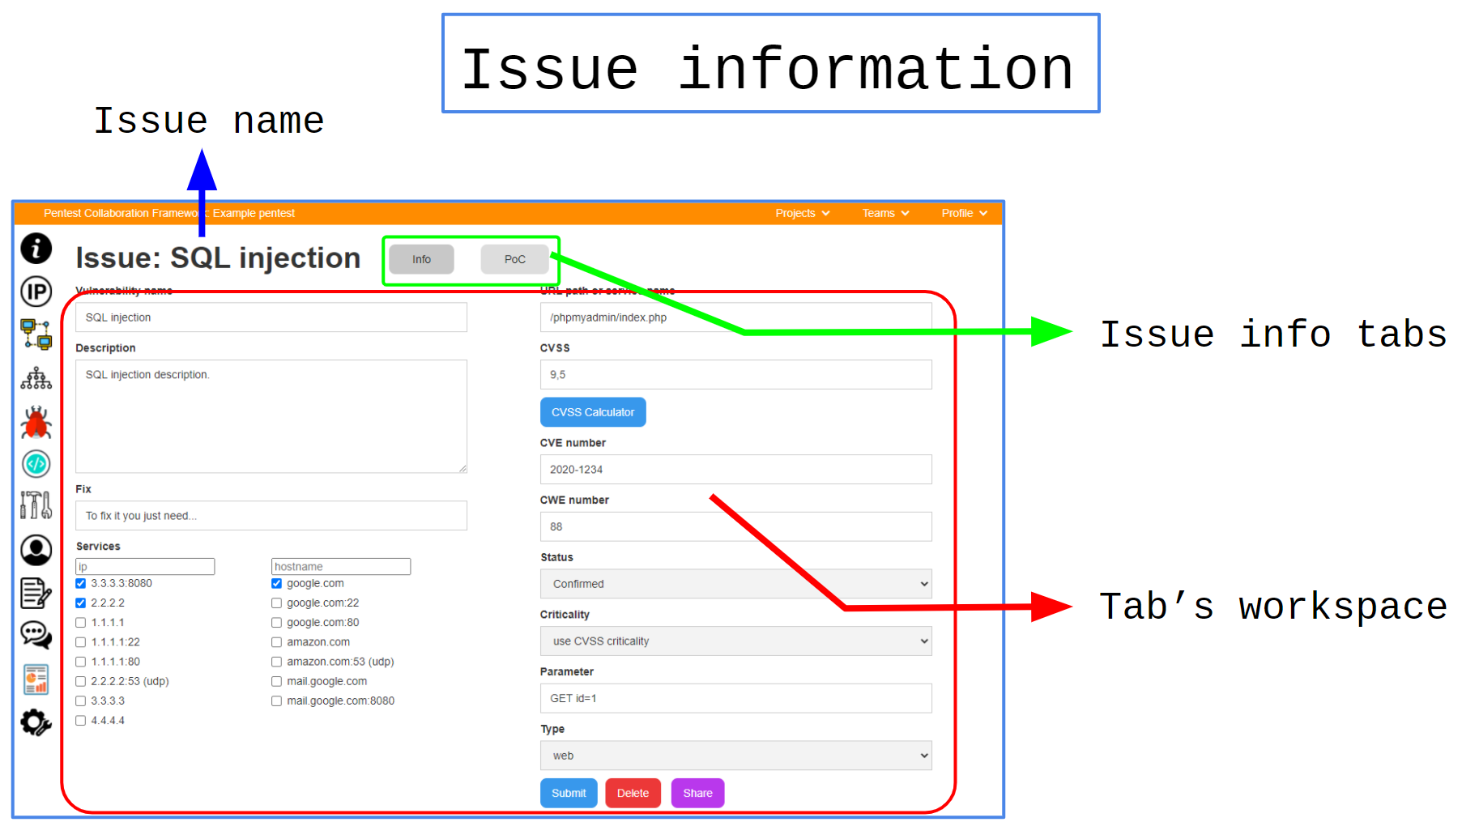 **Issue information: edit form**

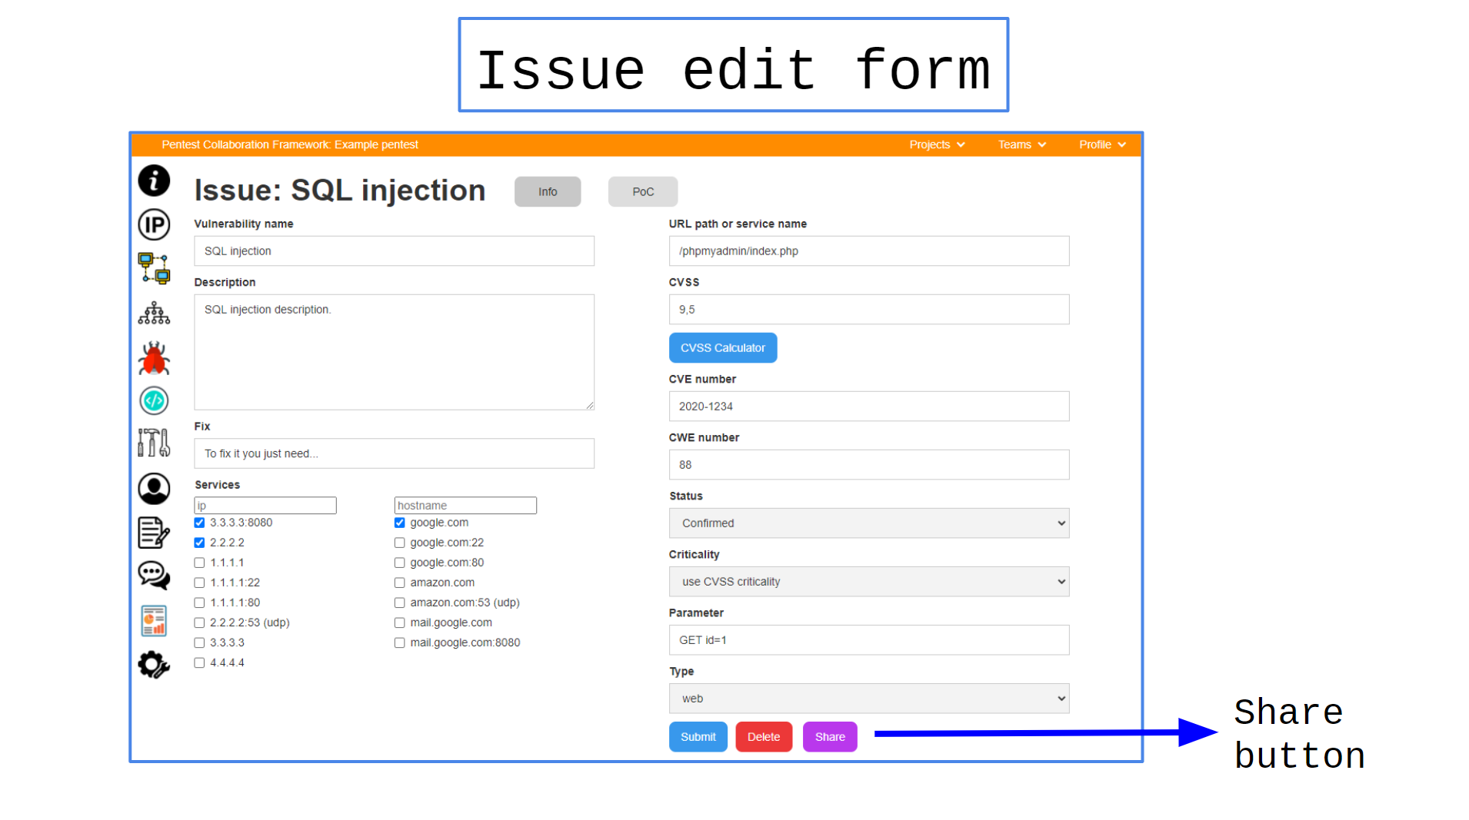**Issue information: PoC form**

**Proof-of-Concept can be a text file or image.**

Symbol (near PoC) - final version of PoCs ( for Reports ).

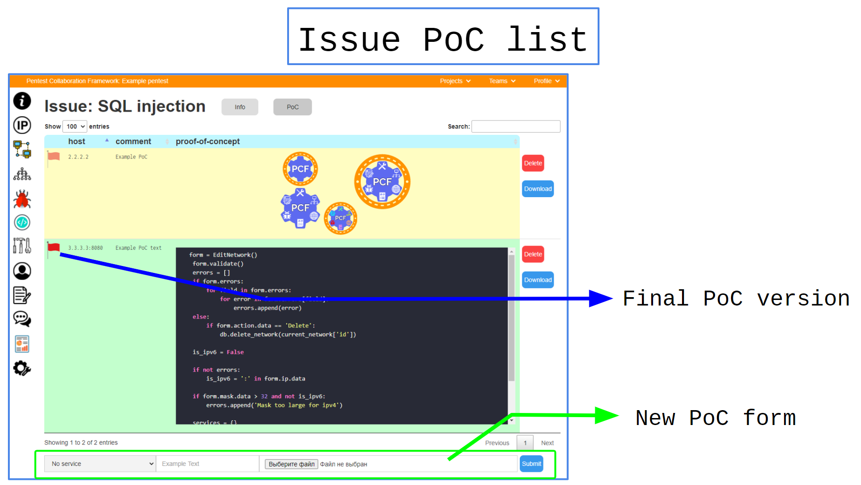

**Shared issue info**

| Name | Value |
| --- | --- |
| URL | /share/issue/{{issue_uuid}}/ |
| URL example | /share/issue/3037349b-0111-4a62-a92d-4d10c5337daf/ |
| Description | Share issue information. |
| Capabilities | Share issue information with unauthorized users. |
| Comments | You can just send this link to system administrators. The page is the same, as issue information link. |

### ****Issue Templates****

**Templates list**

**You can find templates list at /profile or team page:**

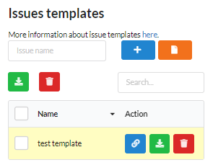 **Here you can:**

* Download (JSON)
* View/Edit
* Create a new template

**Template creation**

**To create an issue template, you need to open configuration tab at /profile or team page:**

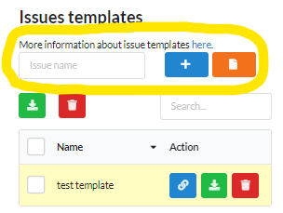 **There are two variants of template creation:**

* Create a new template
* Create a new template from existed issue.
* Import templates JSON.

**New Template Creation**

**1. Set a template name**



**2. Select owner of template**

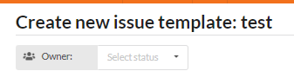 **3. Create required variables  
  
There are four types of required variables:**

* Text
* Number
* Float
* Boolean

**For example, create a text-variable vuln-username:**

**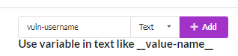  
  
  
  
  
This variable will be automatically saved into clipboard as "__vuln-username__", so you can use it at next steps: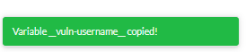 Also you can edit created variables at "Required variables" tab:**

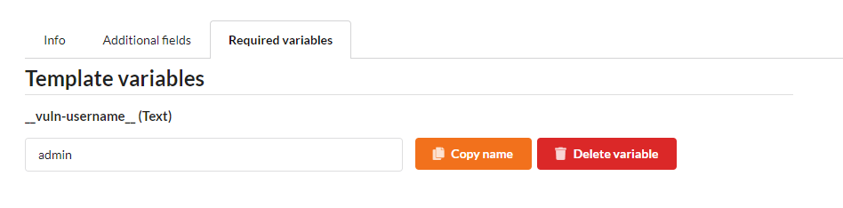 **So, it's better to set a default variable value not to forget what this variable means in the future. At previous screenshot we set default value "admin" for variable "__vuln-username__".**

**4. Fulfill issue fields**

**You must fullfill main issue fields. For example, you can fullfiil issue description and fix fields and insert into them required variable "__vuln-username__”:**

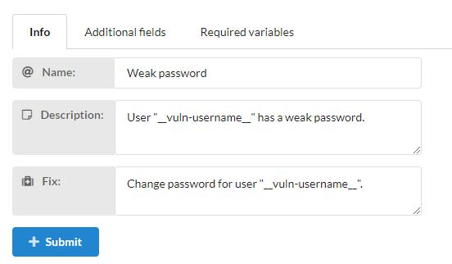 **So, when you use this issue template, variable name will be replaced with variable value (by default, variable "__vuln-username__" will be replaced with string "admin").**

**5. Save template**

**To save a template, you must click at submit button:**

 **Create a template from an existing template**

**To create an issue template from an existing issue, you must click at “New template” button at issue page:**

 **And next you will be redirected at fulfilled form from previous paragraph.**

**Template edit**

**To edit template, you must open a configuration tab at /profile or team page and click at blue button:**

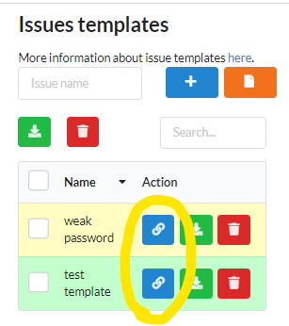 **All next steps of template edition are the same as the new template creation steps.**

**Template usage**

**To use a template, you must click at "Add from template" green button at top right corner of issues list page and select needed template:**

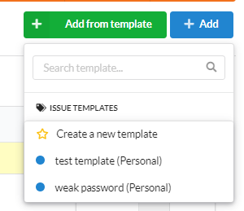 **After this you will be redirected at new page where you need to insert required variables at left and see a result of new issue:**

**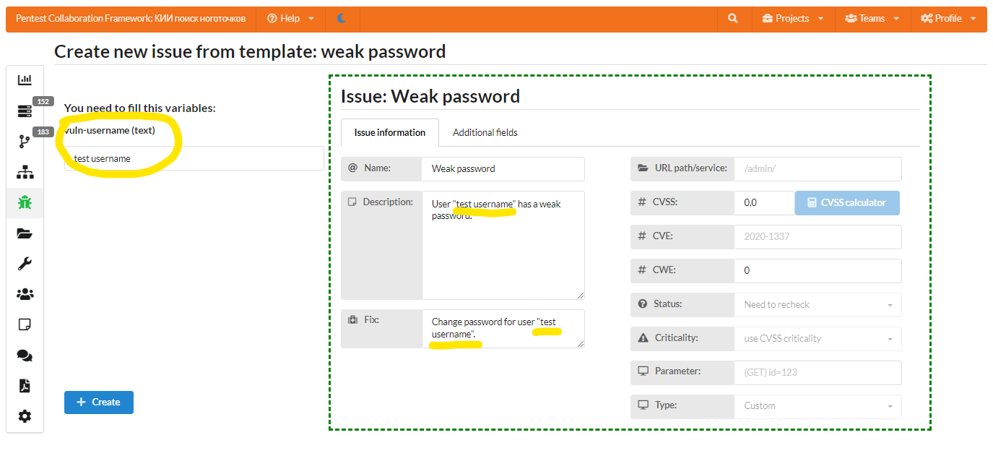  
And next click at blue button "Create":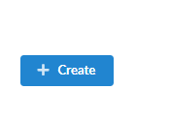 And next you will be redirected at new created issue.**

**Issue templates JSON**

**To export and import template issues, you can use JSON-format.**

**Example of JSON-file**

**[**

{

"cve": "",

"cvss": 0.0,

"cwe": 0,

"description": "User \"__vuln-username__\" has a weak password.",

"fields": {},

"fix": "Change password for user \"__vuln-username__\".",

"name": "Weak password",

"param": "",

"status": "Need to recheck",

"tpl_name": "weak password",

"type": "custom",

"url_path": "",

"variables": {

"vuln-username": {

"type": "text",

"value": "admin"

}

}

}

]

**Import**

**To import templates, you must use this link:  
  
  
  
  
  
  
  
Then you will be redirected at /import_issue_templates page, which you must to fullfill: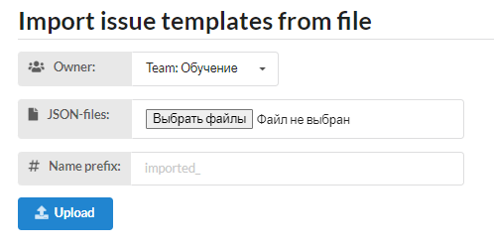 There are three parameters:**

* Owner - personal or team
* JSON-files - one or multiple json files
* Name prefix - prefix of imported issue templates.

**After that click on the Upload button:**

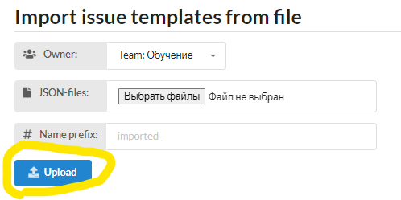 **Export**

**To export issue templates, you can:**

* **export one issue template**
* export multiple issue templates

To export one issue template, you just need to click at green download button:

**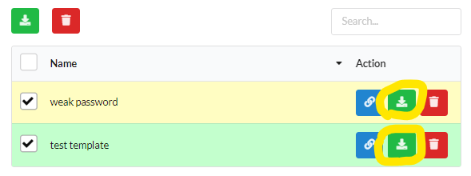  
  
  
  
  
  
To export multiple issue templates, you must select them using first column checkboxes and click green download button at top of table: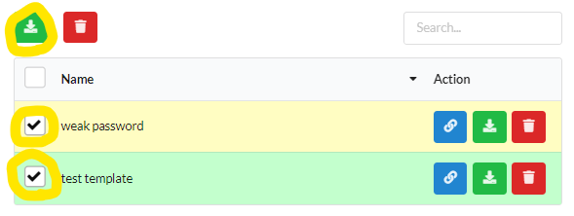 After that, your browser will download issue template .json file.**

### ****Issue rules****

**Rules logics**

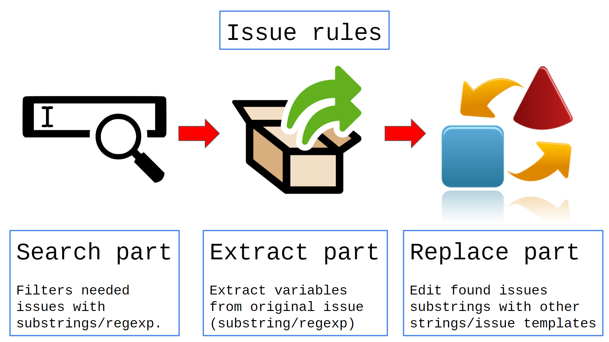 **Issue rule - an object which consists of three parts:**

1. Search rules - rules which filters needed issues
2. Extract rules - rules to extract variables(substrings) from issue
3. Replace rules - rules to replace issue content with strings/issue templates.

It can be used for massive edition of imported scanner results (1 rule == 1 scanner result) or other automated actions.

**Search rules**

**Search rules - rules which filters needed issues.**

It can be:

* Substring rule - you just must set field name and substring to search for.
* RegExp rule - same, but, instead of substring, it uses python regular expressions to search issues.

**Extract rules**

**Extract rules - rules to extract variables(substrings) from issue.**

Same as "Search rules" uses "Substring" or "RegExp" methods. This part extracts some special strings from original Issue, which can be used at next part.

**Replace rules**

**Replace rules - rules to replace issue content with strings/issue templates.**

Replace rules can be two types:

* Template rule - you must set template and it's fields (you can use variables from "Extract rules" inside fields).
* String rule - replace part of issue with string. It can also be "Substring" or "RegExp".

**Create a rule**

**Find create button**

**It can be found at Profile -> Config or Team -> Config.**

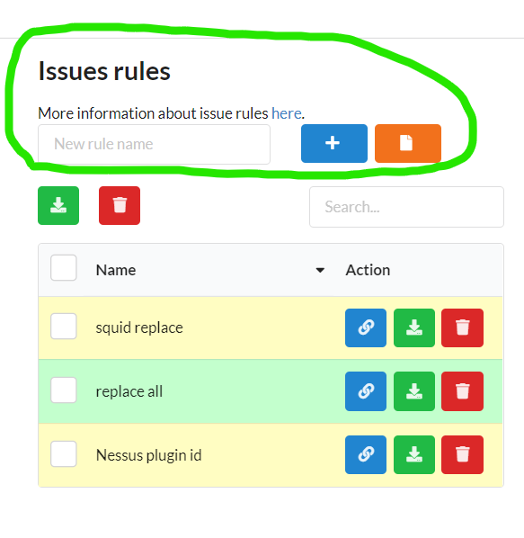 **Set search rule**

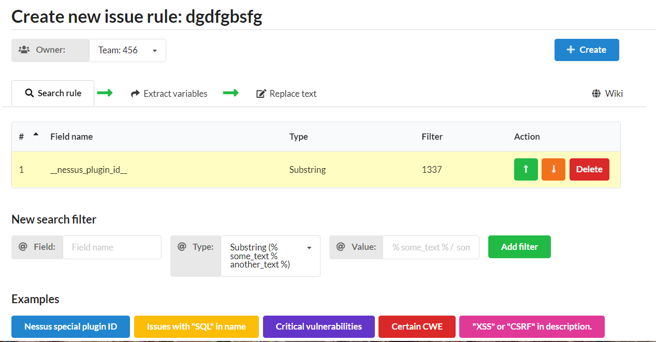**Set search rule - rule, which will filter issues.  
  
  
Set extract rule  
It's not necessary if you will not use variables at "Replace rules" part.**

This rule will create variable names from issue fields substrings.

For example, you can create variable "name" and use it with "{{name}}" (without spaces!!!).

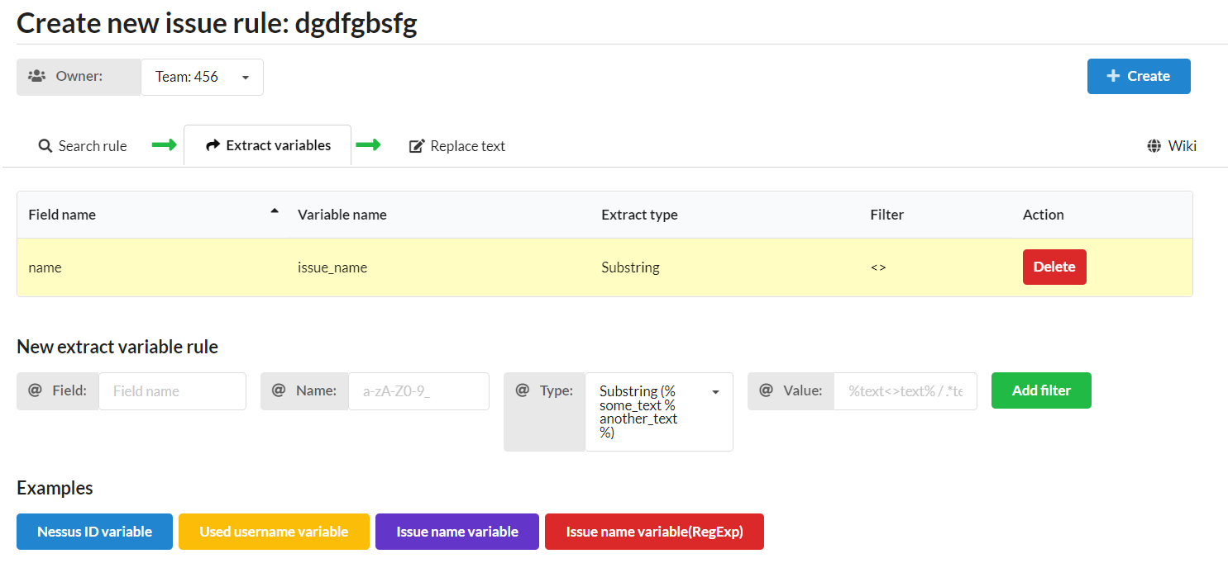

**Set Replace Rules  
You can set two replace rule types: template and strings. Template rules always will be in priority (due to this replaces all issue fields):**

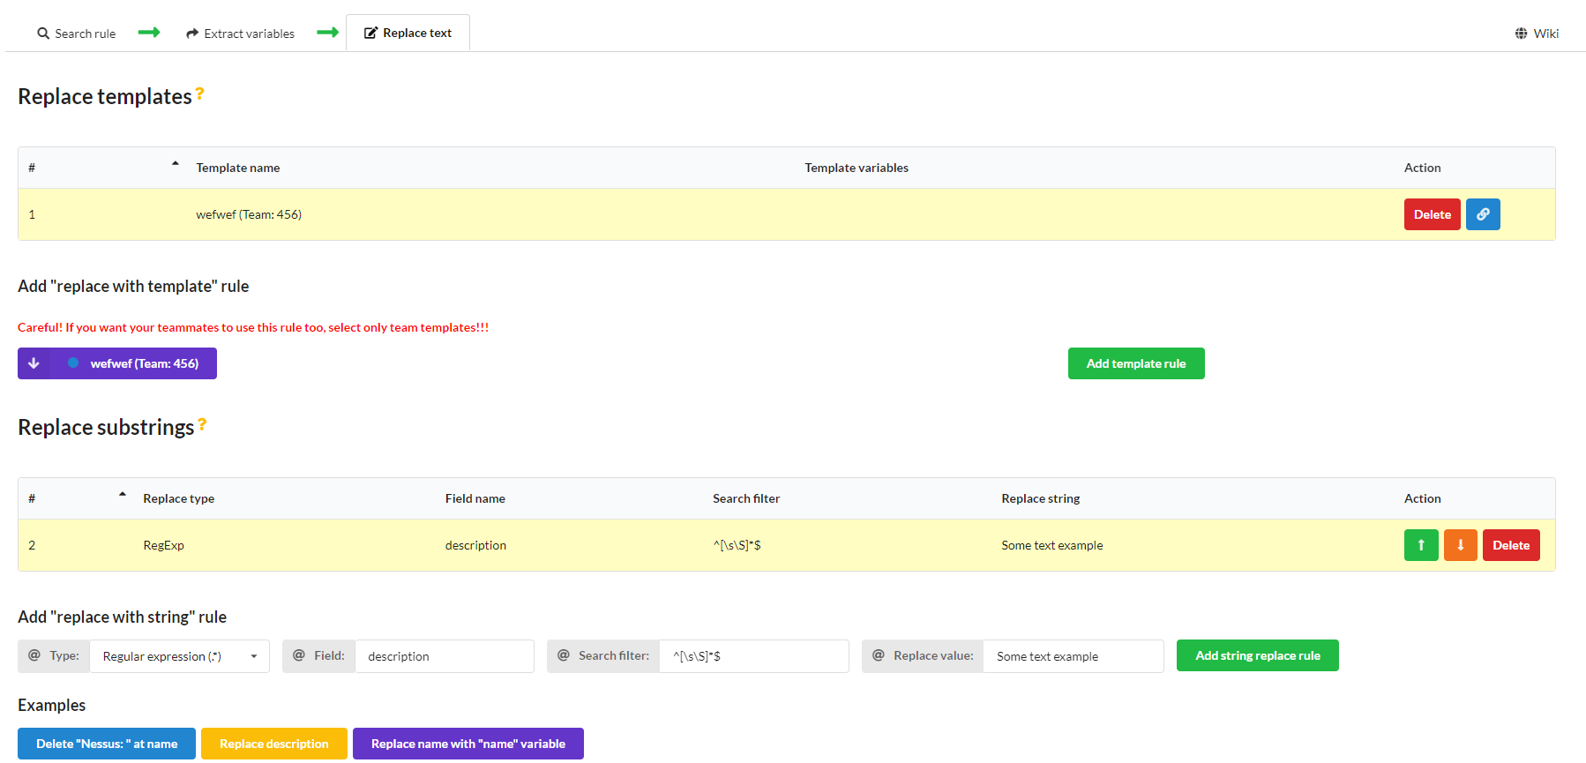 **Use rules**

**Open project issues  
Open project issues, select needed issues and click at this button at the top of the page:**

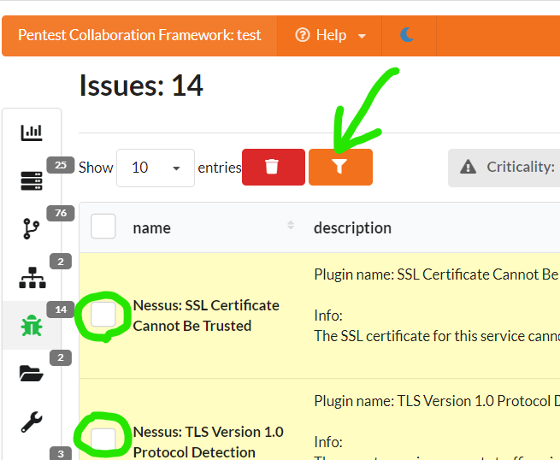

**Select issues and rules**

**Select issues(first column) and rules(second column) and press "Submit" button:**

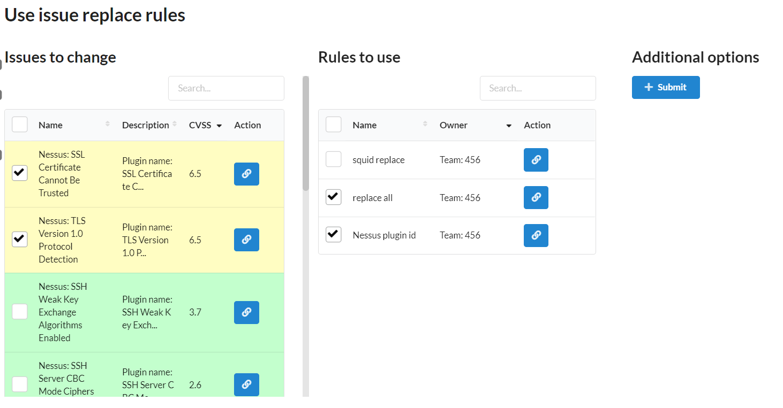

**It will use selected rules at selected issues.**

**JSON features**

**You can also download/upload issue rules using JSON-files.**

**Download**

**Select rules at Profile -> Configs or Team -> Configs pages:**

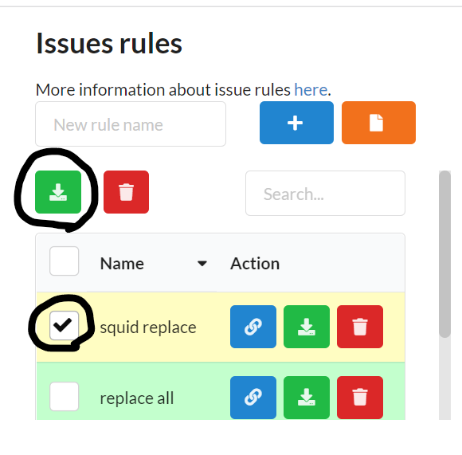 **Example of JSON:**

**[**

{

"extract_vars": [

{

"field_name": "name",

"name": "test_name",

"type": "regexp",

"value": "^([\\s\\S]*)$"

}

],

"name": "Nessus plugin id",

"replace_rules": [

{

"id": "cc7ebb3f-64eb-41a2-81a9-7b30ba04dffb",

"md5": "3c82edeeb913f84a2b81b9a027b5db3a",

"type": "template",

"vars": {

"service-name": "text {{test_name}} text"

}

},

{

"field_name": "fix",

"replace_string": "New{{test_name}} string",

"search_filter": "^[\\s\\S]*$",

"type": "regexp"

}

],

"search_rules": [

{

"field_name": "__nessus_plugin_id__",

"type": "substring",

"value": "150154"

}

]

}

]

**Upload**

**You just need to press this button:**

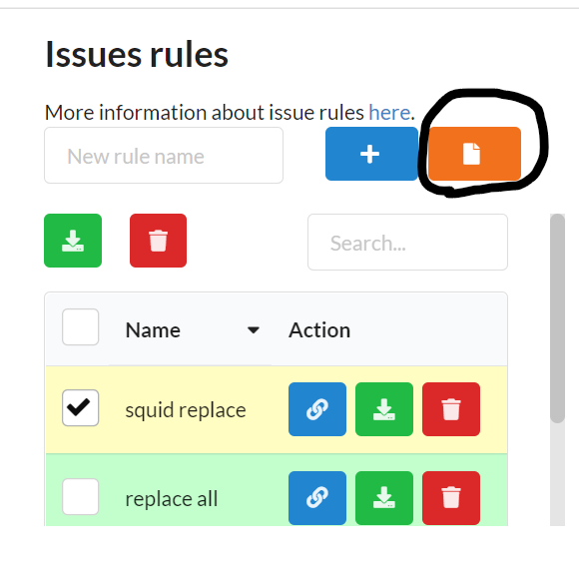

**If you use issue templates inside rules, it will try:**

1. Search for issue template by its ID and check if owner of template is this team/profile.
2. Search for issue template by its MD5-checksum and check if owner of template is this team/profile.

If it doesn't find template, it will not be added to new created rule.

**Restrictions**

* **If you want others to use created rule, check that they have access to used issue templates**
* There are some time limits for operations due to fix ReDOS attack (2 sec for any RegExp operation)

## ****Reports moderation****

### ****Sequencing****

| № | Action |
| --- | --- |
| 1 | Open new network form |
| 2 | Add new project network |
| 3 | Check it at networks list page |
| 4 | Get visualized network at networks list page |

### ****Tutorial****

**Next steps will help you to generate report with template. If you want to get just JSON project file - go to** Endpoints **part.**

**Step no 1: choose template type**

**There are three types of templates:**

1. **Plaintext files** - just file with template fields. It can be any type: .txt, .html, .tex and so on. There is an example of Latex .tex template inside [/report/examples](https://gitlab.com/invuls/pentest-projects/pcf/-/tree/master/documentation/report/examples) folder.
2. **ZIP archive** - zip archive with plaintext/docx files. Any time you use this type of template - you need to set plaintext file extention or "docx" (inside .zip) to report creation form:

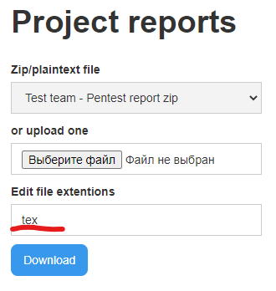

**3. docx files - Best way! It uses crossplatform** [docxtpl](https://pypi.org/project/docxtpl/) **library to parse .docx template and generate a report!****Step №2: examining the template engine**

**All three types uses** [JINJA](https://jinja.palletsprojects.com/en/2.11.x/) **template engine!**

(.docx template also have some additional jinja tags)

Example report.txt file:

**{% for i in example_array %}**

{{index.loop}}

{% endfor %}

**Step №3: creating template**

**You must learn how to insert project variables inside template, so we created variable name map, which you can find at** [/documentation/report/report_fields.txt](https://gitlab.com/invuls/pentest-projects/pcf/-/blob/master/documentation/report/report_fields.txt)

Fragment of file:

**. . .**

2. issues {issue_id}

2.1 name

2.2 cve

2.3 cwe

2.4 cvss

2.5 criticality [critical, high, medium, low, info]

2.6 services {port_id}

2.6.1 ip

2.6.2 is_ip # True/False

2.6.3 hostnames [hostname_id,...]

. . .

5. ports {port_id}

5.1 port

5.2 is_tcp # True / False

5.3 comment

5.4 service

. . .

**.. and the example of creating list of issues:**

**{% for issue_id in issues %}**

Name - {{issues[issue_id]['name']}}

{% if criticality=='critical' %}

!!!RED ALERT!!!

{% endif -%}

{% set services = issues[issue_id]['services'] -%}

{% for port_id in services -%}

{% if ports[port_id]['port']== 0 %}

WHOLE HOST!

{% else %}

JUST {{ports[port_id]['port']}} port :)

{% endif %}

{% endfor -%}

{% endfor -%}

**Example output:**

Name - SQL injection

WHOLE HOST!

JUST 8080 port :)

WHOLE HOST!

Name - XXE

Name - CSRF

Name - PHP version disclosure

**Step №4: save template (optional)**

**You can save team template at** Teams page **or personal templates at** Personal page**.**

**Step №5: use template**

**If you saved it before - you just need to select it from drop-down menu:**

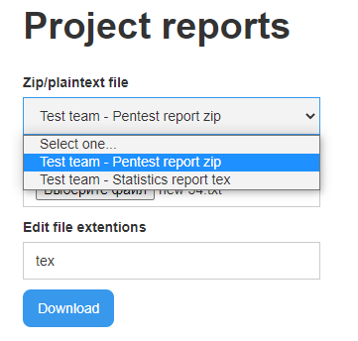

**or upload it with file upload form and press Download button!**

**Don't forget to set plaintext/docx filetypes (saved in .zip) even if you saved .zip template before!**

### ****Endpoints****

**Reports page**

| Name | Value |
| --- | --- |
| URL | /project/{{project_uuid}}/reports/ |
| URL example | /project/53ade0ed-ea2d-4812-9676-8bdcf5b7412c/reports/ |
| Description | Project report generation page. |
| Capabilities | 1. Generate report from template 2. Get JSON of project. |
| Comments | - |

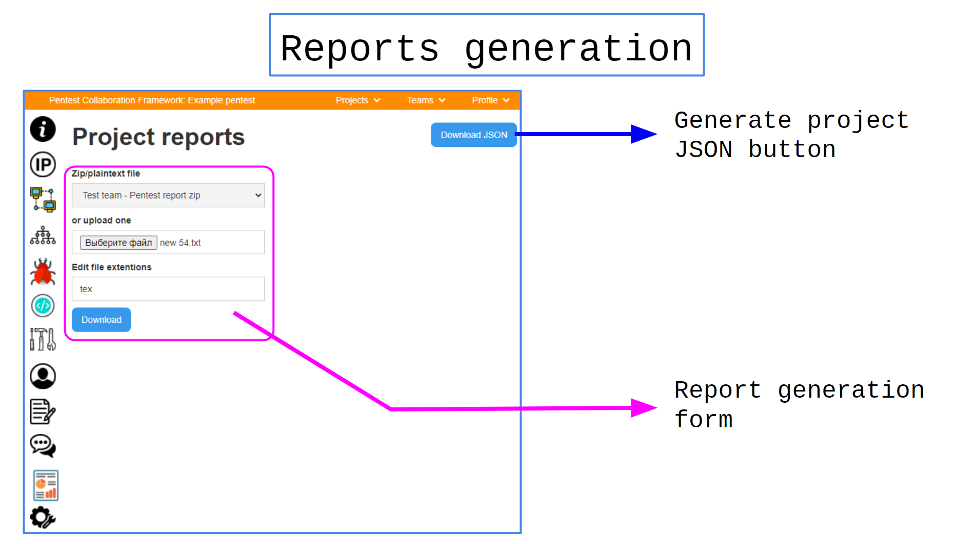 **JSON Project download**

| Name | Value |
| --- | --- |
| URL | /project/{{project_uuid}}/reports/export/json |
| URL example | /project/53ade0ed-ea2d-4812-9676-8bdcf5b7412c/reports/export/json |
| Description | Project JSON generation page. |
| Capabilities | Generated JSON file of project. |
| Comments | - |

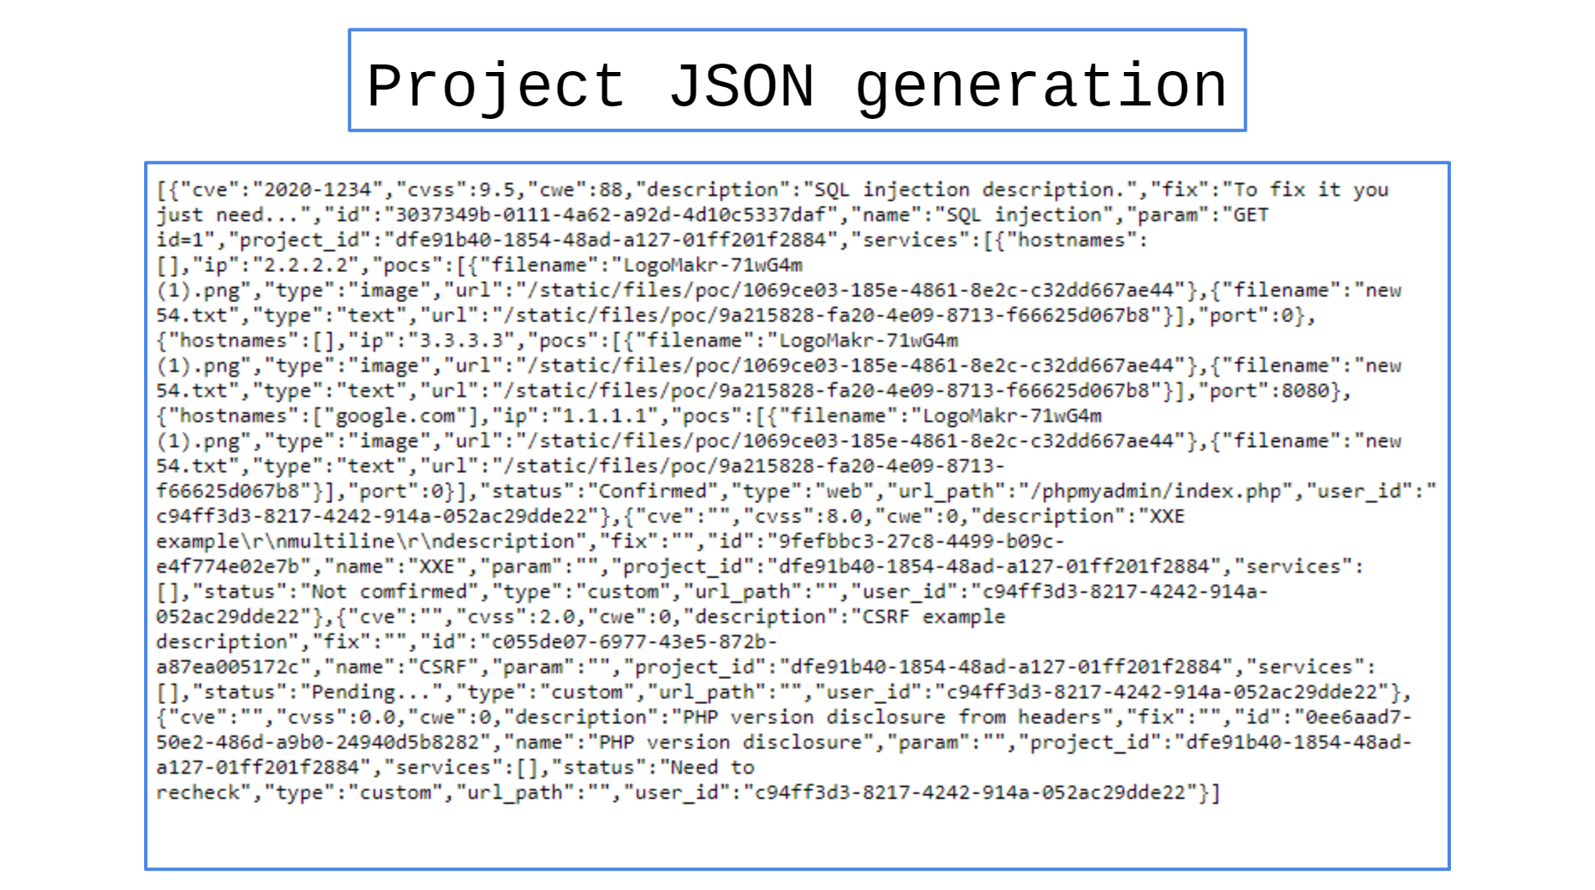

## ****Files moderation****

### ****Sequencing****

| № | Action |
| --- | --- |
| 1 | Open project files list |
| 2 | Add a new text/image/binary file |
| 3 | View it |

**You can change some file options at ️****️Settings** **page!**

### ****Endpoints****

**Files list**

| Name | Value |
| --- | --- |
| URL | /project/{{project_uuid}}/files/ |
| URL example | /project/53ade0ed-ea2d-4812-9676-8bdcf5b7412c/files/ |
| Description | Project files list. |
| Capabilities | 1. View/modify project files  2. Upload file form |
| Comments | - |

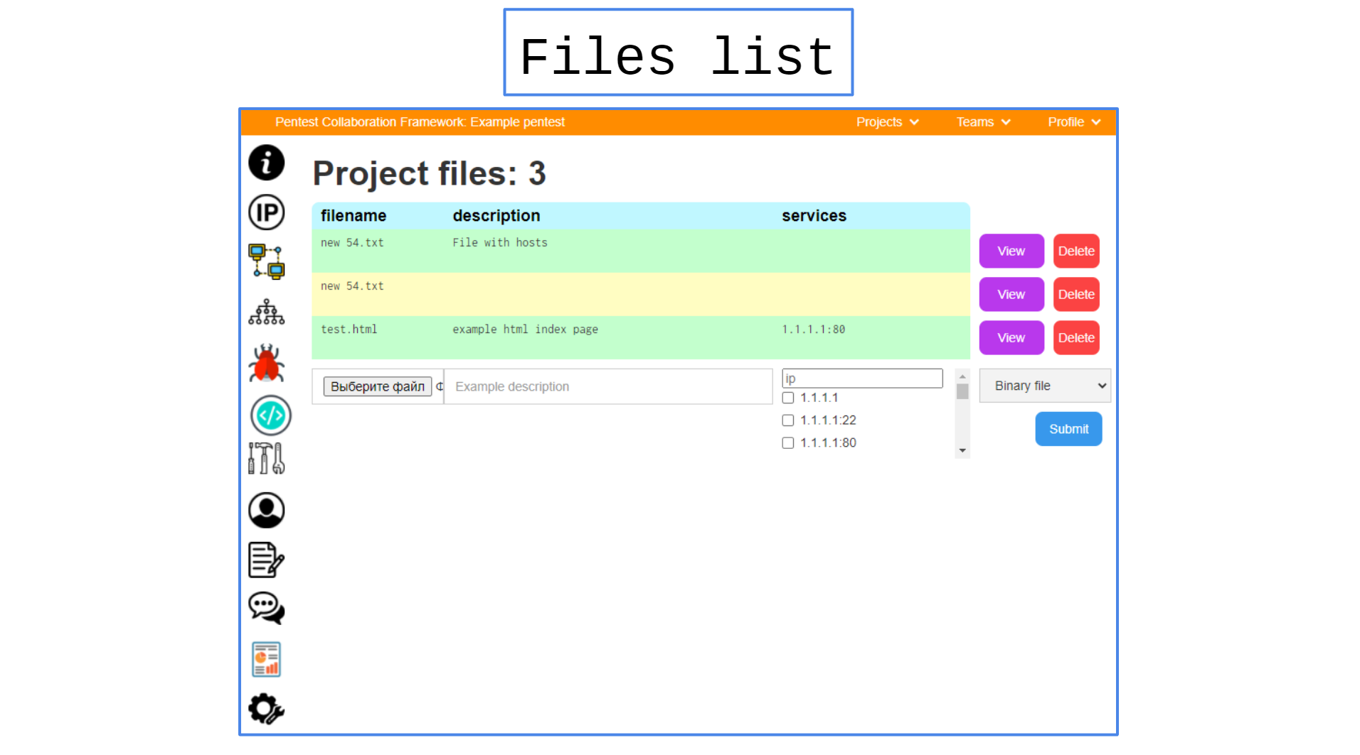 **File viewer**

| Name | Value |
| --- | --- |
| URL | /project/{{project_uuid}}/files/{{file_uuid}}/ |
| URL example | /project/53ade0ed-ea2d-4812-9676-8bdcf5b7412c/files/a87172bf-b226-43d9-92fd-ef16672a8d22/ |
| Description | Project file viewer. |
| Capabilities | View/Download/Remove files |
| Comments | - |

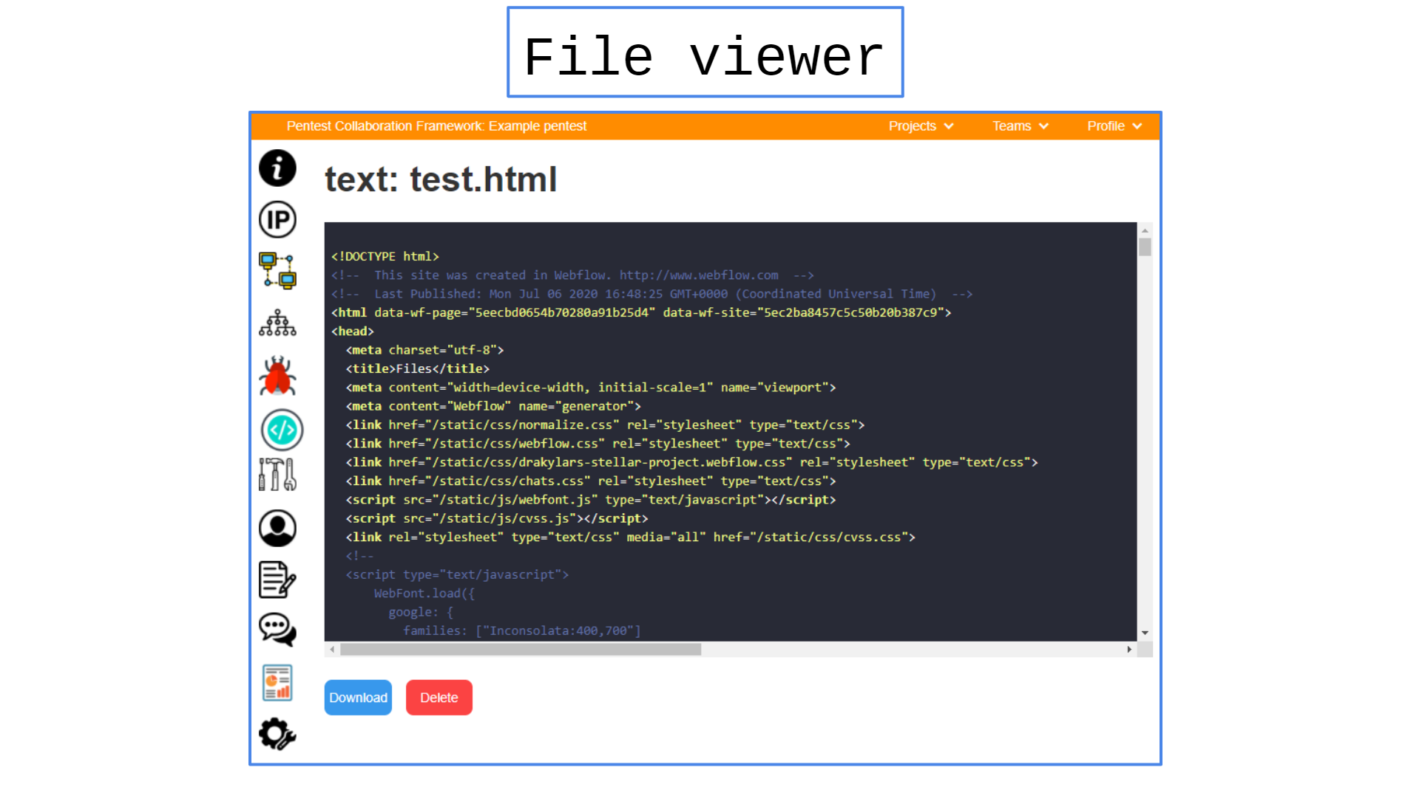 **File download**

| Name | Value |
| --- | --- |
| URL | /static/files/code/{{file_uuid}} |
| URL example | /static/files/code/a87172bf-b226-43d9-92fd-ef16672a8d22 |
| Description | Project file downloader. |
| Capabilities | Download file by uuid |
| Comments | - |

## ****Credentials moderation****

### ****Sequencing****

| № | Action |
| --- | --- |
| 1 | Open project credentials list |
| 2 | Add new found credentials |
| 3 | Check their information |
| 4 | Export credentials |

**You can change some credentials options at ️****️Settings** **page!**

### ****Endpoints****

**Credentials list**

| Name | Value |
| --- | --- |
| URL | /project/{{project_uuid}}/credentials/ |
| URL example | /project/53ade0ed-ea2d-4812-9676-8bdcf5b7412c/credentials/ |
| Description | Project credentials list. |
| Capabilities | List of credentials. |
| Comments | - |

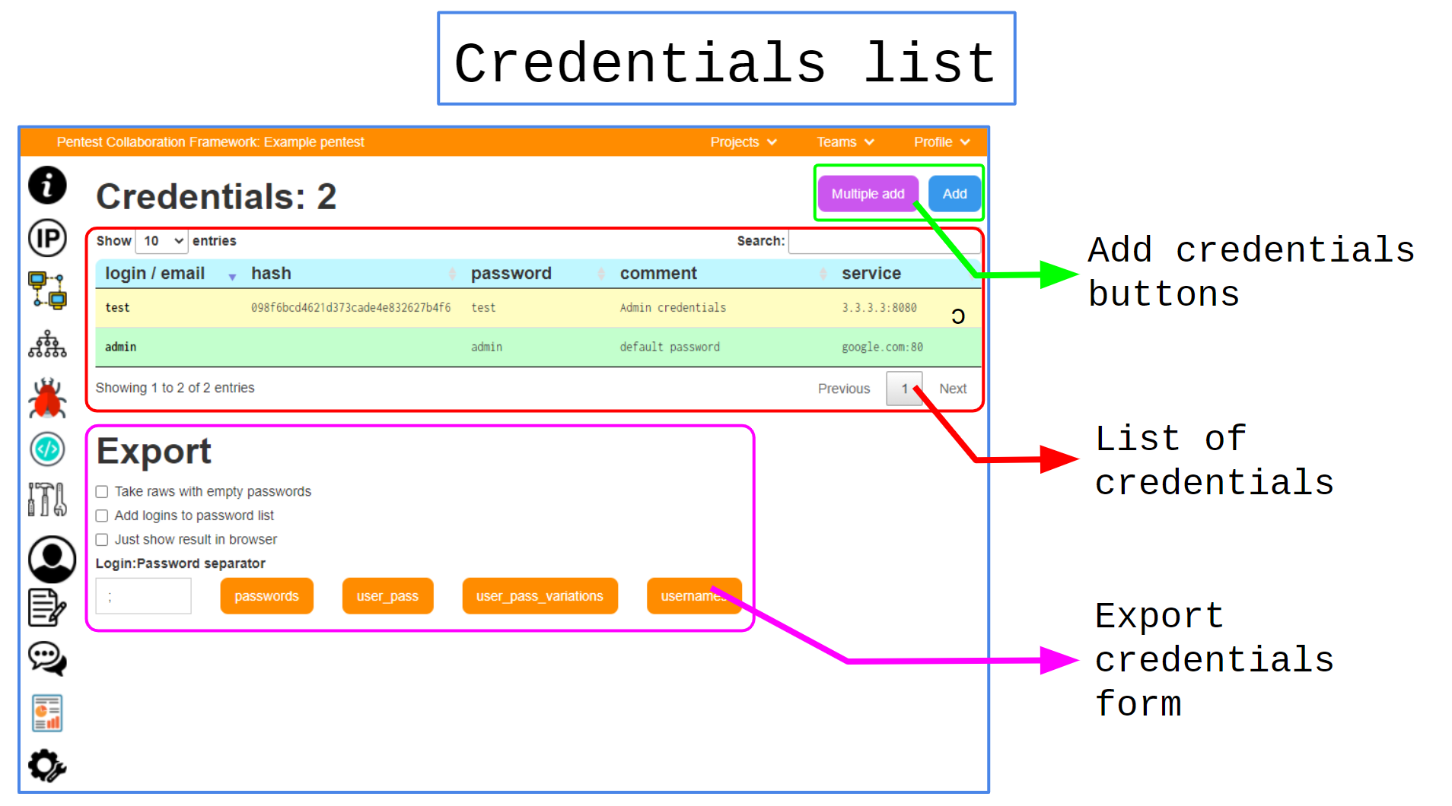 **Add single credentials**

| Name | Value |
| --- | --- |
| URL | /project/{{project_uuid}}/credentials/new_creds |
| URL example | /project/53ade0ed-ea2d-4812-9676-8bdcf5b7412c/credentials/new_creds |
| Description | Add new single credentials. |
| Capabilities | Add new project single credentials form. |
| Comments | - |

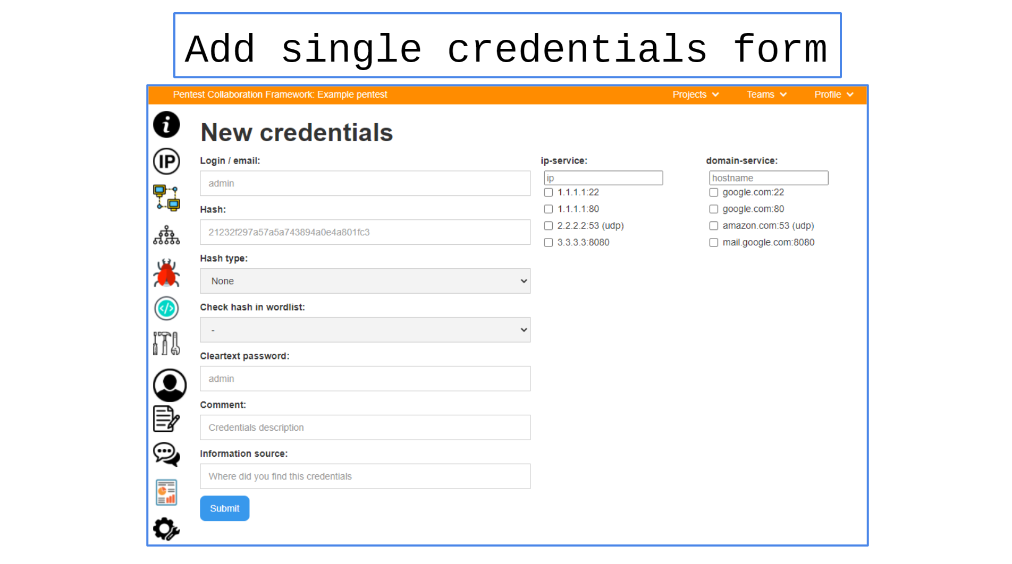 **Add multiple credentials**

| Name | Value |
| --- | --- |
| URL | /project/{{project_uuid}}/credentials/import_creds |
| URL example | /project/53ade0ed-ea2d-4812-9676-8bdcf5b7412c/credentials/import_creds |
| Description | Add multiple credentials. |
| Capabilities | Add new project multiple credentials form. |
| Comments | - |

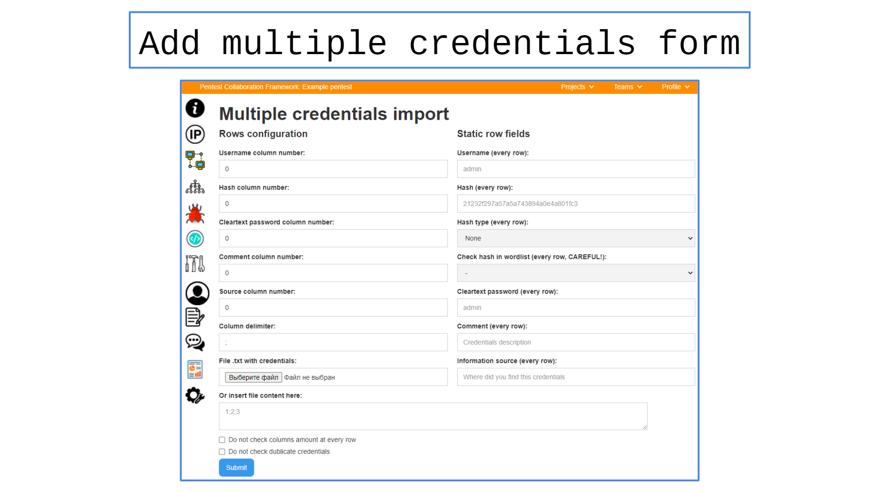 **Credentials Information**

| Name | Value |
| --- | --- |
| URL | /project/{{project_uuid}}/credentials/{{credentials_uuid}} |
| URL example | /project/53ade0ed-ea2d-4812-9676-8bdcf5b7412c/credentials/6f81a2bf-4767-41e1-a7f3-e8ce0f3318a6/ |
| Description | Credentials information page. |
| Capabilities | View/edit credentials information. |
| Comments | - |

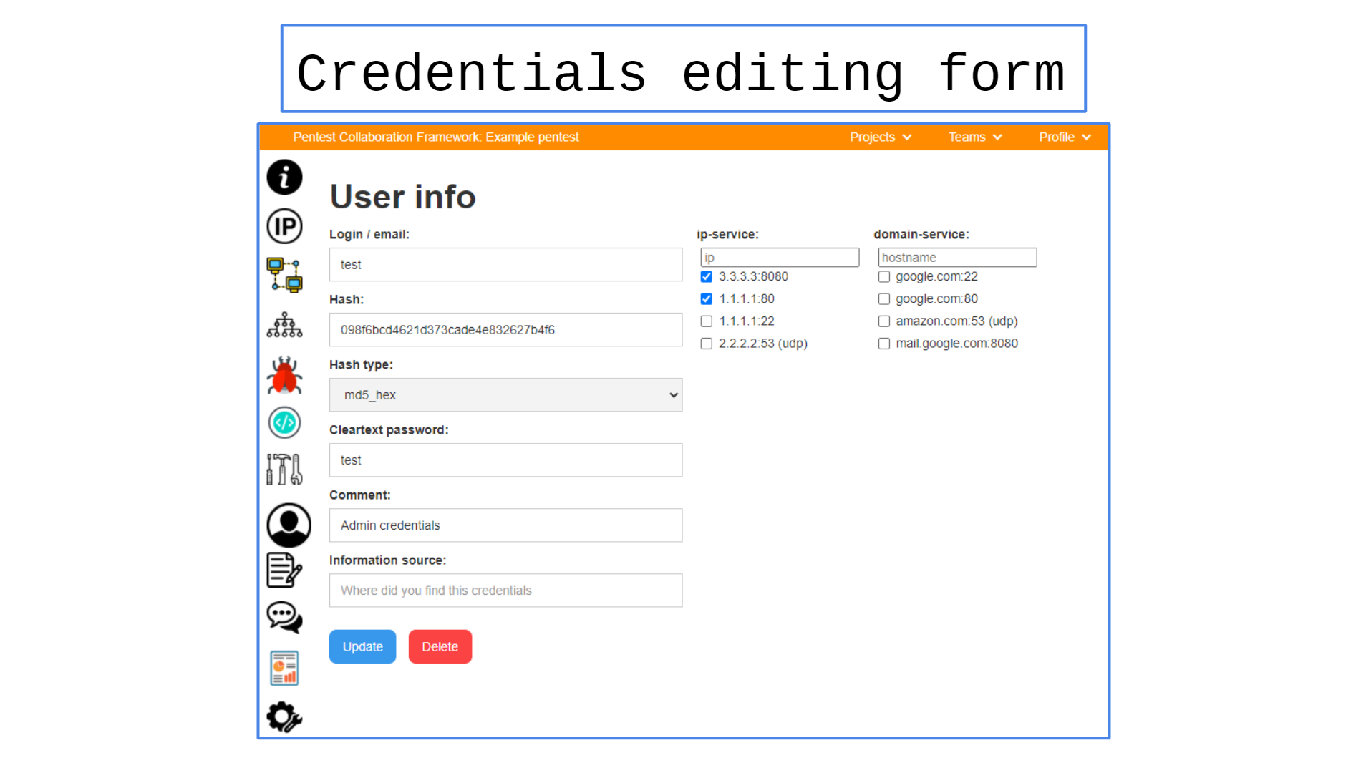

## ****Notes moderation****

### ****Sequencing****

| № | Action |
| --- | --- |
| 1 | Open project notes page |
| 2 | Create new note |
| 3 | Update note text |

### ****Endpoints****

**Notes Page**

| Name | Value |
| --- | --- |
| URL | /project/{{project_uuid}}/notes/ |
| URL example | /project/53ade0ed-ea2d-4812-9676-8bdcf5b7412c/notes/ |
| Description | Project notes page. |
| Capabilities | 1. View/edit existed notes 2. Create new notes. |
| Comments | - |

## ****Chats moderation****

### ****Sequencing****

| № | Action |
| --- | --- |
| 1 | Open project chats page |
| 2 | Create a new chat |
| 3 | Start chatting |

### ****Endpoints****

**Chats Page**

| Name | Value |
| --- | --- |
| URL | /project/{{project_uuid}}/chats/ |
| URL example | /project/53ade0ed-ea2d-4812-9676-8bdcf5b7412c/chats/ |
| Description | Project chats list. |
| Capabilities | Create chats, send messages. |
| Comments | - |

## ****Tools Usage****

### ****Supported tools****

| ****Tool name**** | Integration type | Description |
| --- | --- | --- |
| Nmap | Import | Import XML results (ip, port, service type, service version, hostnames, os). Supported plugins: vulners |
| Nessus | Import | Import .nessus results (ip, port, service type, security issues, os) |
| Qualys | Import | Import .xml results (ip, port, service type, security issues) |
| Masscan | Import | Import XML results (ip, port) |
| Nikto | Import | Import XML, CSV, JSON results (issue, ip, port) |
| Acunetix | Import | Import XML results (ip, port, issue) |
| Burp Suite Enterprise | Import | Import HTML results (ip, port, hostname, issue, poc) |
| kube-hunter | Import | Import JSON result (ip, port, service, issue) |
| Checkmarx SAST | Import | Import XML/CSV results (code info, issue) |
| Dependency-check | Import | Import XML results (code issues) |
| OpenVAS/GVM | Import | Import XML results (ip, port, hostname, issue) |
| NetSparker | Import | Import XML results (ip, port, hostname, issue) |
| [BurpSuite](https://gitlab.com/invuls/pentest-projects/pcf_tools/pcf-burpsuite-extention/-/tree/master/out/artifacts/burp_jar) | Import/Extention | Extention for fast issue send from burpsuite. |
| WPScan | Import | Import JSON results (ip, port, hostname, issue) |
| DNSrecon | Import | Import JSON/CSV/XML results (ip, port, hostname) |
| theHarvester | Import | Import XML results (ip, hostname) |
| Metasploit | Import | Import XML project (ip, port, hostname, issue) |
| Nuclei | Import | Import JSON results (ip, hostname, port, issue) |
| PingCastle | Import | Import XML results (ip, issue) |
| MaxPatrol | Import | Import XML results (ip, port, issue) |
| Scanvus | Import | Import JSON report (issue) |